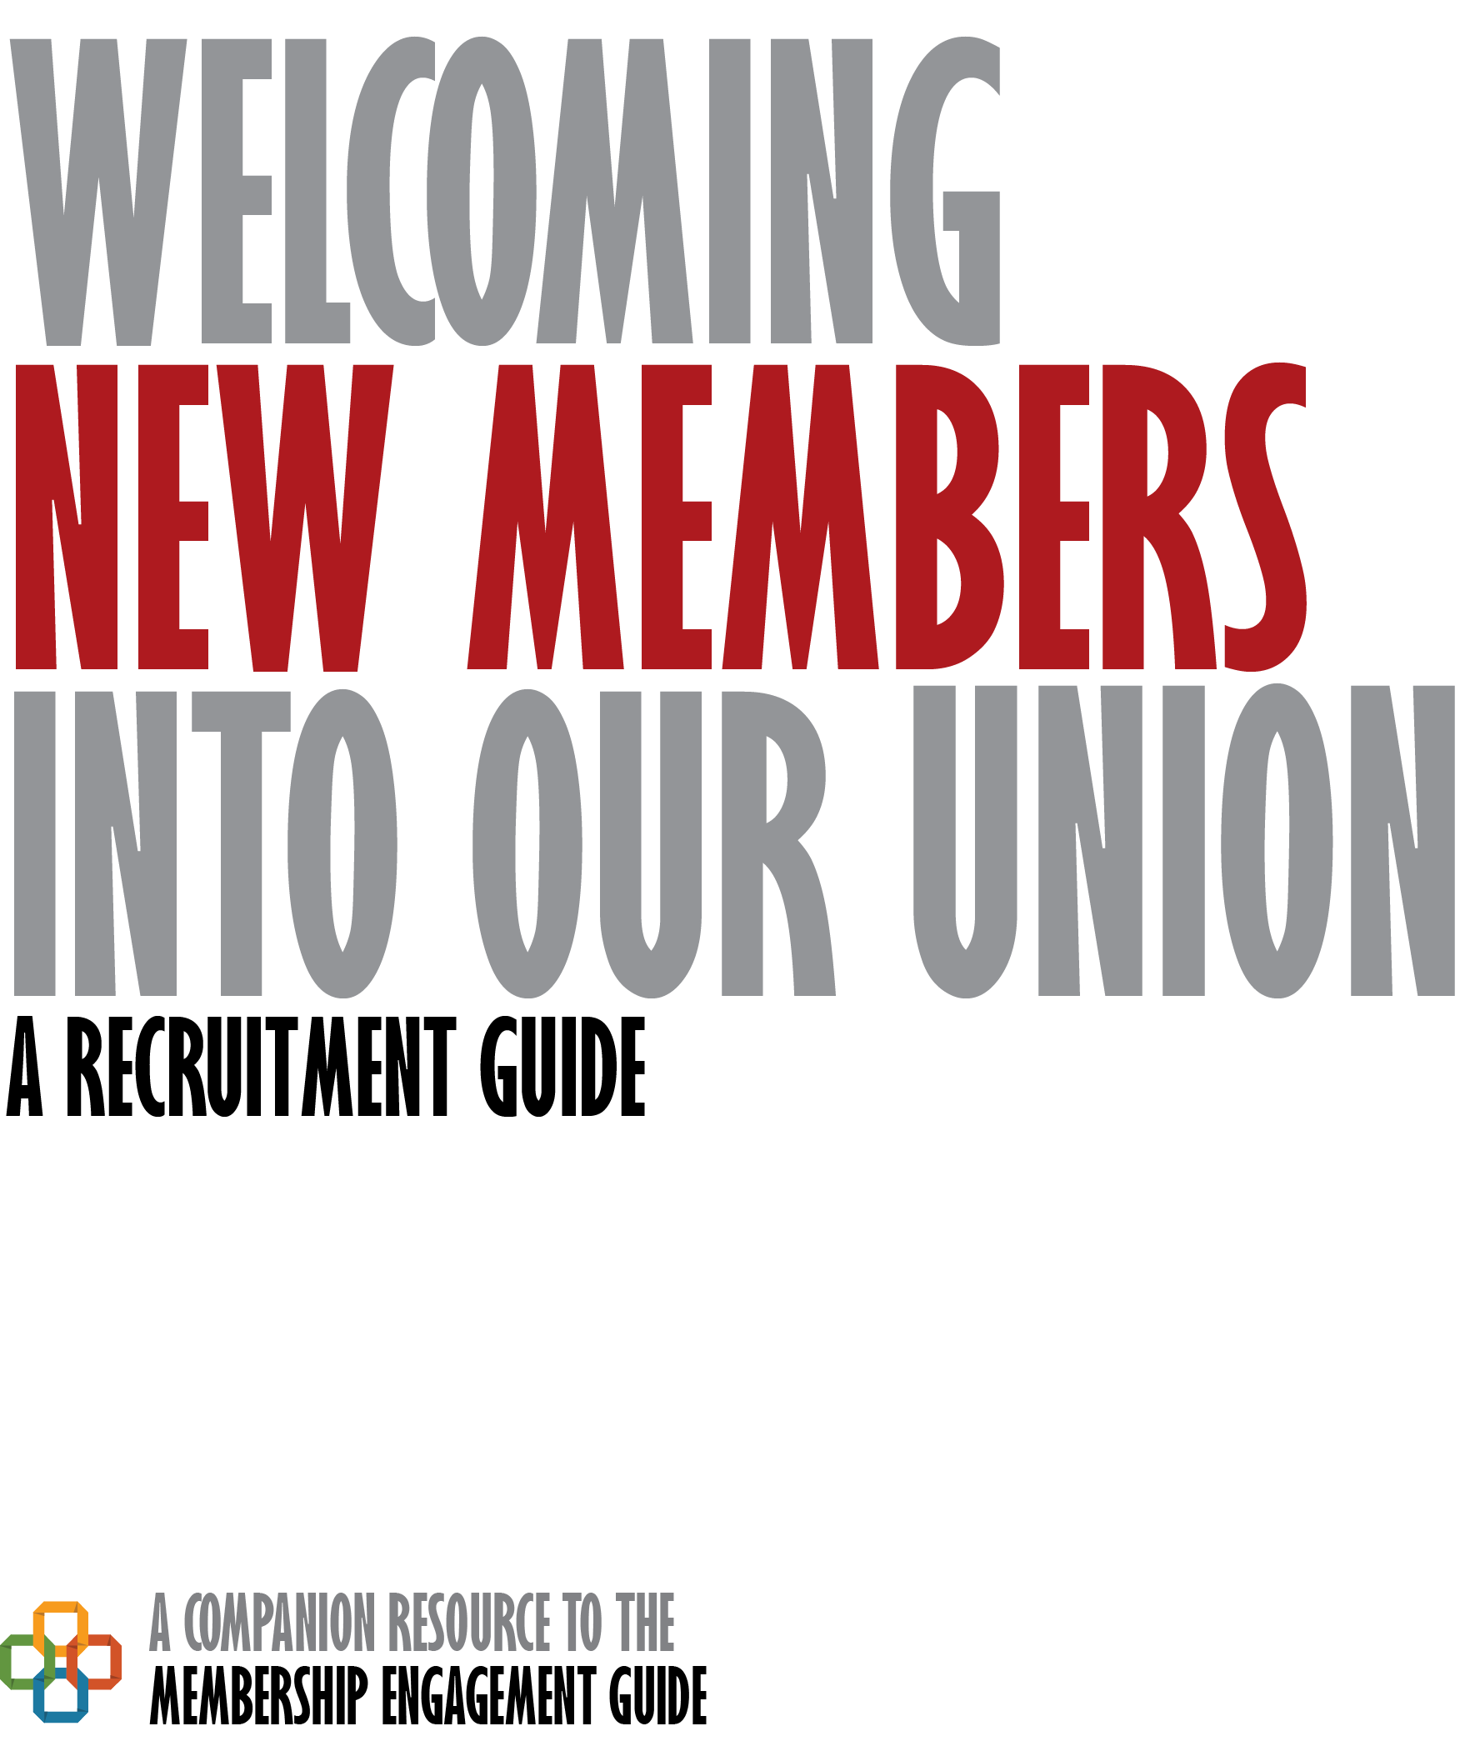

M
embership is the key to everything we do in our association. Maintaining high membership is our source of power at the bargaining table and in the workplace. Maintaining high membership requires recruitment and engagement of all members. It requires asking potential members to join, educating members and potential members about the history of union membership, benefits of belonging, and engaging members in issues and activities that are important to them in their personal and professional lives. While membership recruitment and engagement activities and strategies are addressed in the Membership Engagement Guide, this resource is a tool to assist local leaders in focusing on membership recruitment.
Table of Contents
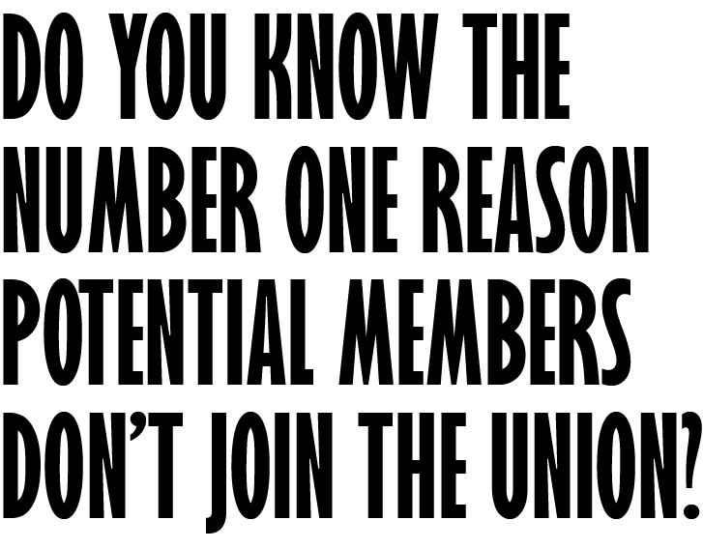
Understanding New Educators 4
Survey Says
Embracing Generational Differences

The Art of the Conversation 7
Relational Organizing: It Takes Conversation
Conversation Styles
Share Your and the Association’s Story
Strategies and Suggestions
Things You Should Not Do
Address Objections by Potential Members
Information You Need to Know or Be Familiar With
Suggested Resources for the Membership Recruitment
Before You Start Conversing with a Potential Member, Stop and Prepare
Once You Are Prepared

Using the Materials 18
How to Use the Recruitment Brochure with Potential Members

Every leader in the association should be prepared and responsible for reaching out to and recruiting new members. While most member recruitment efforts are concentrated at the beginning of the school year, anytime is a good time to welcome a new member.
Membership recruitment is about relational organizing and making personal connections. Few people join the association without being asked. In fact, the number one reason potential members do not join is because no one asked them to join. The most successful membership recruitment activity involves having a one-to-one conversation with a potential member, in which you actively listen, shares his/her own story about why membership matters to him/her, shares information about the association’s values and accomplishments, and provides resources and materials that are pertinent to the potential member’s personal and professional life. And CTA is here to help you do just that!

But first…

We need to Understand New Educators

Survey Says
Findings are from a December 2015 survey of 1,282 new teachers (less than 10 years) in California.

Key Findings
- Feeling supported is the strongest driver of professional satisfaction. This is not a new finding – we have found this connection in prior surveys.

- Contact with members (how frequently and recently we have reached out to them) is the strongest driver of union satisfaction, loyalty and commitment.

- Knowing that NOT paying fair share fees could weaken the union to the point where it could no longer negotiate wages, benefits and working conditions is the strongest reason for maintaining membership.

Other Findings
Early career teachers are discouraged with professional conditions, and become more discouraged with experience. However, new teachers in California are more optimistic than those nationally. | Right now, teachers turn to colleagues and informal networks for support. The union is not yet an essential part of their support network. This is an opportunity. | Just a third felt very well-prepared by their prep programs when they entered the profession.
They have widespread access to formal development and support systems. The issue they raise is quality. | While they give their union high ratings, they are largely unfamiliar with what the union does. | There are clear opportunities for CTA and locals to become essential to new teachers’ professional lives– formal support drops dramatically after year one, which contributes to professional dissatisfaction.

Takeaways
Get to know each new educator. Listen. Empathize. | Find out how you can support them (Mentoring, buddy program, etc.). | Invite them to local union events and check in with them throughout the year. | Share your story and the union story. Our history and victories. “We are your seat at the table.” | Share resources from NEA/CTA and your local chapter that could be helpful for a newer educator and/or invite them to a CTA conference.

Embrace Generational Differences
As you begin talking with new members, remember they may have different perspectives and experiences—many just because of their age differences. Perhaps your local association, like CTA, is undergoing a generational transformation and Millennials will soon make up a major portion of the membership. But right now, Gen Xers make up the majority of CTA’s members. Baby Boomer members and leaders who led efforts to win collective bargaining rights and negotiate our initial contracts have retired, or will soon retire. Consider that people communicate based on their generational backgrounds and that each generation has distinct attitudes, behaviors, expectations and motivations. So, as you plan and prepare to meet with potential members, keep generational differences in mind. Regardless of generation, plan to include an educational component about the history and value of the association.
- Gen Z’s are the latest generation to join the education ranks-and they have already made their presence felt. Passionate about social justice and climate issues, they are post-materialistic and ready to be the change they want to see in the world.
- Millennials make up the largest, most watched over and most diverse generation in American history. They tend to be team and task oriented. They are civic oriented, but not necessarily in a “union march” kind of way. Millennials were likely not raised in union households, as they grew up in an era of union decline. Messages of support, unity, and community are generally appealing to this audience. Use of technology in communications is a must. And while they value the work we do to secure good salaries and benefits, they are also interested in surviving the first years on the job, personal recognition, improving the profession and student-centered education changes.

- Gen-Xers were born and raised as independent latch-key kids, Gen Xers tend to be more independent. Watergate, Vietnam, Gay Rights and the Women’s movement peppered their youth. They are in mid-career, so messages that enable them to share their expertise or speak to transforming the profession resonate well.

- Baby Boomers were crusaders in their youth, questioning authority, and became the “Me Generation.” In later years, many became workaholics and many are retiring now. Messages around preserving benefits and protecting public education are usually effective. To connect with potential members from all these generations we cannot talk at them, we must talk with them. Give them the tools to create their own stories, memories and experiences.
To connect with potential members from all these generations we cannot talk at them, we must talk with them. Give them the tools to create their own stories, memories and experiences.
In varying degrees, here are some things all potential members tell us they want:
- Support networks and resources to do the job
- A better explanation of what the association is all about
- Positive relationships with others (less concerned about needing legal resources or grievance representation)
- Professional development and opportunities for networking
- Meaningful participation in the association

Mastering the Art of the Conversation

Relational Organizing: It Takes Conversation
Member recruiting methods such as putting membership forms in staff boxes at the worksite or offering member discounts on various services will not, by itself, convince a person to become a member. Relational organizing through one-to-one conversations is essential in recruiting membership to strengthen the association.
In these one-to-one conversations make sure you listen more than talk, engage the potential members in open-ended conversation, and look for opportunities to invite them to join instead of lecturing them to join the association. Be focused on listening to the potential member to understand his/her interests. Share your personal story/experience. Relate the value the association can bring to him/her in the hope the person will want to stand with us. One-to-one conversations allow us to identify and address issues at the local, state or national level. Conversations also allow us to identify potential association activists and leaders.
Remember, educators didn’t become educators to join the union, they became educators so they can work with and educate students. The most fruitful conversations will identify those issues that either support or stand in the way of educators’ ability to educate and support students. It is critical that these conversations be natural, inviting and positive.

Conversation Styles
It is important to be yourself and keep your conversations earnest.

Remember to BE:
- RELAXED: Relax and remember you know more than you need to share in one conversation
- HONEST: Your credibility is crucial – don’t jeopardize it
- BRIEF: Speak simply, avoid technical jargon or fancy language
- ATTENTIVE: Give the prospective new member your full attention
- PERSONAL: Use personal stories or anecdotes – it makes the story, and you, more credible
- CONSISTENT: Keep your goals for the interaction in mind and stick to them
- ENERGETIC: Keep the tone of your voice upbeat and conversational
- SINCERE: Avoid saying “no comment”
- HUMOROUS: When appropriate, use humor
- COOL: Maintain your politeness – don’t allow yourself to be baited
Find a way to start conversations and couple or relate issues in a manner that you are most comfortable. Consider the use of “F.O.R.M.;” “AHUY;” “Feel, Felt, Found;” and “Bridging.”

F.O.R.M.
The first step in organizing is to talk to a potential member and learn more about him/her. F.O.R.M. is a simple acronym that helps organizers remember to touch on all aspects of a potential member’s life to learn more about the person.
F | Family (e.g., “I have two kids at this school. Do you have any children?)
O | Occupation (e.g., “I became a teacher because I really like history and kids. Why did you go into teaching?)
R | Recreation (e.g., “A lot of us at this school, like to walk at lunch. Do you think you’d like to join us?”)
M | Message (e.g., “At some point, I’d like to tell you more about our local association and why I’m a member. Can we get together again on _____?”)

By talking about things you may have in common, it is easy to help potential members see that they will feel comfortable belonging to the association. Sometimes potential members will be ready to join immediately (for example, you may learn that they were an active union member at their last job).

AHUY
The “AHUY” framework for one-to-one conversations attempts to identify those issues that matter to new or veteran educators and uses organizing around those issues as a focus for union involvement and collective action. The AHUY model for one-to-one conversations was developed and used by the United Farm Workers.
The AHUY conversation helps potential members move past feelings of hopelessness or procrastination and assures them that they can make a difference through collective action. The first step toward collective action would be joining the local union.
The AHUY acronym spells out the conversation steps used in a one-to-one conversation that is directed toward getting the potential member to do something such as joining the association, going to a board meeting or filing a grievance.
A | ANGER: This step is designed to agitate by asking the potential member what is bothering him/her. (e.g., “How do you think this principal is treating staff unfairly?” or “Why don’t you think teachers have enough tech support?”)
H | HOPE: Discuss how things could be better, especially through collective action.
U | URGENCY: Discuss why now is the time to act or join the union and why tomorrow may be too late to make a difference.
Y | YOU: Tell the potential member that he or she can make a difference. (e.g., “Your voice is important, especially when you join with others saying the same thing. Together we can make a difference.”)

Feel, Felt, Found
The “Feel, Felt, Found” conversation is an effective one-to-one conversational frame for dealing with objections or hesitation on the part of potential members. If you approach a potential member with an invitation to join your local association and are met with “I really don’t see any reason to join,” use the following conversational frame to keep the conversation going:
FEEL | “I know how you feel.”  “Hey, I get it. I never gave unions much thought either. I guess I thought I could take care of myself in just about any situation.”
FELT | “I have felt the same way myself.”  “In fact, I was pretty resentful when a union rep. convinced the principal that I wasn’t experienced enough to handle an upper-grade class.”
FOUND | “But, I found that….”  “It turned out, though, that the union really helped when I had a payroll dispute with the district. When the district refused to place me on the correct salary step, the union hired a lawyer and the district ended up owing me a lot of money for back pay.”

Bridging
Use “bridging” statements, which are helpful in transitioning your conversation. The following are bridging statements:
- “That’s an interesting question - - Let me remind you though…”
- “That’s a good point, but I think your audience would be interested in knowing that…”
- “While _____ is certainly important, don’t forget that ____ is…”
- “That’s an important point because…”
- “What’s important to remember, however, is…”
- “What I really want to talk with you about is…”
- “What’s most important here is…”
- “And don’t forget…”
- “Before we get off on that topic, let me add…”
- “That’s not my area of expertise, but what I can tell you is…”
- “Let me just add…”

Share Your Story and Your Association’s Story

Your Story
Besides listening to a potential member’s interests and issues, it is important to earnestly share “Your Story.”
When you are conversing with a potential member for the first time, you should share “Your Story” based on why and how you got into education, your job classification, how long have you been working in public education, your passion for the work you do, and, maybe, one of your prideful moments working in education.
In the second or subsequent meeting, share “Your Story” about how and why you become involved in the local association and how it has made a difference in your professional and personal life. Connect with the potential member on matters that you have in common.
Write “Your Story” down for yourself. It helps you remember issues that are important in the work you do, be it in your employment or in the association.

Your Association’s Story
Be prepared to deliver a consistent message about your local association, CTA and NEA. What is your local association’s mission, vision and goals? What are your association’s goals in bargaining to improve working conditions in your district? What has your local association done to make your school(s) a better place for learning? Share CTA’s and NEA’s mission, goals and history.
When you develop your local association’s story, keep in mind:
- When the union fights for better working conditions for educators, it is also working for better learning conditions for students.
- When the union fights for job protections for educators, it is also working to ensure that children have access to the best knowledge and the best instructional strategies available.
- When the union fights for reasonable pay, it is fighting to attract high-quality candidates to the profession and retain them.

Strategies and Suggestions
Most importantly in all your conversations, remember that people join organizations because they want to belong, affiliate and have a sense of collective power. Consider these strategies and suggestions:
- Assume the person will join the association. Start with this assumption because it changes your outlook and approach when starting the conversation. If you believe a person won’t want to join or can’t afford the dues, you will be defeated before you start!
- Know and learn from your audience. Know who you are talking with as you can anticipate relevant issues that the potential member may bring up or may be of interest to him/her. Tailor your talking points accordingly. Remain open to learning new things about the potential member. Strong associations build relationships with their members and potential members.
- Peer- to- peer conversations are best. There is often common interests and experience between unit members when they work in the same department, grade level or at the same worksite.
- Be positive and represent the association well. Share the value, mission, goals and history of the association/CTA/NEA, as appropriate, to help the potential member understand the purpose of the association and why it is relevant to them as educators. Let the person know that the association is the educators’ professional organization with professional development services. We are not just a labor union.
- Approach each and every potential member. Some of us freeze when we have to approach a colleague to join the association because we fear the person will say “no.” But, as an association member and leader, you have a story to tell, you know the value of your membership in the association, and can speak confidently with first-hand experience. Remember, the #1 reason people give for not joining is, “No one ever approached me.” Don’t let that be said in your association.
- Don’t try to “sell” membership, instead have an earnest conversation. People respond best to issues relevant to them. Find out as much as possible about who this person is, what they care about, and help them understand how the association is available to address and meet their needs. Respond to the person’s interests and issues, instead of giving the person a “canned” membership pitch. Each person needs to be approached differently. Answer their questions about the association.
- Use the personal approach for each potential member. “I understand you are a new teacher. Did you know that NEA has a professional library and offers professional development that may be of assistance to you?” “I hear you were just assigned a new student as a support staff person. Did you know that CTA provides very useful training and resources for support staff who work one-on-one with students?”
- Convey a friendly, helpful attitude. Remember, you are representing your association and positive representatives help to convey a positive organization. Regardless of what is said, keep your cool and professionalism! Exude confidence and enthusiasm. Be constantly optimistic about what the association can accomplish.
- Handle criticism by putting it to work. “I’m awfully glad that you are as concerned as I am about that problem. You’re just the person to join a committee we’re forming to address the problem.”
- Stress the fact that the strength and effectiveness of the association increases as the size of the membership grows. Our collective power means a great deal when negotiating our contract or fighting for a worksite issue.
- Working in pairs is often helpful. A colleague who has personal credibility, or who is an avid association member, can often make a big difference in the success of the discussion. When necessary, assign a different person to go back on the second contact.
- It’s in the member’s best interest! It counts when the association negotiates a good contract. It counts when the local association lobbies for full funding of the contract or legislation. It counts when the association lobbies successfully for educational change. It really counts when a member is in a jam and needs legal assistance. There’s a great deal more at stake than just more members – the individual member’s welfare is at stake.
- Its people not paper! Brochures are only a means to an end. Be strategic in your use. By themselves, printed pieces of information will almost never get a potential member to join. Most materials placed in a mailbox will not even be read. If you do use the materials, deliver them in-person and discuss them. Only use a membership material item as it makes sense for the potential member.
- For long-time non-members, use an affirmative question such as “What can we do to get you to become a member?” and then truly listen to their response. This approach brings people into the association in an engaging way.
- Always fill out the membership form as much as possible before making contact with a potential member. If you don’t have the information, at least highlight the areas that a new member needs to complete on the membership form.
- Don’t leave the membership form with the potential member. Complete as much as possible of the membership form, including the correct dues amount. Always have a pen ready. Make an appointment and come back again.
- Keep track of your contacts with potential members. Make notes about the conversations you have with potential members after you meet. Record issues they raise, questions they may have, and other things that are noteworthy such as their skills and interests. Share this information with the association in the interest of developing programs that members want.
- Follow-up with any prospective member. The best follow-up is always a conversation. Do this respectfully, but persistently. You can then follow-up with a note, email or phone call.
- Remember, people join because of a sense of belonging, shared values, and collective power. People join and are active in organizations when the mission and work of the organization resonates with their priorities and values. If potential members are not aware of what the union stands for or is doing, they are less likely to join. Remember, our ultimate goal is to have active, engaged members who want to be part of the association and continue their membership.

Things You Should Not Do
- Give the potential member a sales pitch before you get to know the person and find out his/her interests.
- Start off the conversation with a horror story in hopes of offering a cautionary tale and then leading into the need for a union. Using fear as a recruitment tool is not an ideal way to build a strong, engaged membership.
- Assume someone will say “no” and not approach the potential member at all, or only ask a yes/no question such as “will you join?”
- Use CTA/NEA Member Benefits as the sole tool to recruit a member. Member benefits are truly an asset to our members, but your association and CTA/NEA have much more to offer beyond the Member Benefits program. Share the mission, goals, and values of the three associations.
- Stuff mailboxes with membership forms and notes, and then expect those who are interested in membership to approach you. A personal, face-to-face approach is much more effective. Schedule a meeting with the potential member and get to know the person.

Address Objections by Potential Members
Be prepared to address objections by potential members. The following are the most often heard objections to joining and some suggested responses to the objections.
#1 “Dues are too expensive. I can’t afford it”
- “How can you afford not to?” Our union increased our salaries and fights to maintain affordable health insurance costs to employees. We are gaining ground, but only because of the union.
- Quote dues in lowest terms – per day, pay period, week, etc.
- “What can you buy for only $_____ a day?” Equate daily amount to what that amount would buy: less than the cost of a Big Mac, a movie, a 6 pack of soda, etc.
- Cite salary increases over recent years, credit association lobbying and/or bargaining and show that dues are a good investment.
- List protections members get 365 days a year for only $_____per day in dues: lobbying; monitoring of state and federal agencies; contract enforcement; bargaining; precedent-setting legal cases; legal defense for members, which prevent others having to face the same thing; etc.
- Equate dues to an investment.
- “You aren’t buying services, you’re buying into a cooperative, democratic organization that is only stronger if you belong.”
- Equate to buying insurance. “You don’t know when you will need it. You don’t wait until your house is on fire to try to buy fire insurance.”
- “Your dues are tax deductible if you file the long form.” Make a chart showing how much people at different tax rates receive back.
- Save through special discounts via CTA and NEA Member Benefits program.” Show ways to save. “In fact, membership can actually save you money if you take advantages of special services opportunities.”
- Personalize using a member who is a single parent, a new employee, or a veteran member who has never had to actually “use” the organization.
- “If you needed an attorney to defend you against charges such as child abuse, injury, etc., how would you pay the bill?”
#2 “Why should I join; I get it for nothing” (for chapters without fair share fees)
- “No one gets it free. Your colleagues in the Local, State and National Association are paying the tab.”
- Show a chart showing what a member receives in benefits and representation vs. a non-member.
- “Members pay dues, which cover the cost of representation of bargaining and contract support for all bargaining unit members, members and non-members (in units which lack agency fee provisions whereby all employees pay their share of the costs of representation). Additionally, dues payment entitles members to vote, hold office, attend meetings and be represented on matters in addition to those covered by the negotiated agreement. It also entitles them to liability insurance and buying privileges reserved for members.”
- “It costs money to represent employees. All who benefit should share that expense.”
- “The time has come when members can no longer afford the luxury of carrying the financial burden of others who have failed to make the commitment to their profession. Forces which oppose public education and public school employee organizations have joined forces. Our collective resources and energies must be directed at those who oppose us from outside the profession. This is possible only when a majority determines the direction that the organization is to take, and works cooperatively with school administrators and boards to solve the problems and challenges we all face.”
- “We should all be working together to make our organization the very best it can be at representing all of us (for locals which do have agency fee agreements).”
- “When you remain a potential member, you are actually joining the side of management, etc.”
- “As a member, you can take an active part in decision making, vote, hold office and have a voice in a democratic, representative organization.”
- “If something happened to you and you needed the association, it would be too late to join and obtain assistance automatically provided to association members.”
#3 “I’d join the Local (or Local/State) but not NEA”
- Our local association, along with the CTA and NEA, is constantly working to protect, promote and strengthen members’ rights. Only the tip of the iceberg shows here at our local. Some unified programs are:
    - UniServ Program
    - Legal Services
    - Professional Development
    - Research
    - Bargaining Assistance
    - Economic Services
    - Human and Civil Rights
- “How would you be affected if a colleague had a problem and no one had resources or simply chose not to fight it? Precedents set in other cases protect all of us.”
#4 “I don’t agree with (fill in the blank) of the Association”
- “Few people agree 100% with any group or organization’s actions. But representative government, in organizations as well as nations, depends on people who ‘pay their dues’ and who participate in decision making. If you don’t agree with some direction the association is taking, join; become active and work to change our course.”
- “Our Association is democratic – no member is required to agree with the majority on every issue. But every member has a chance to try to sway the majority through representative democratic governance structures at every level of the Association. Furthermore, our representative bodies issue the recommendations of the majority; the Association doesn’t attempt to speak for every individual member in every decision.”
- “What if taxpayers in the district could elect not to pay taxes voted in because they objected to something or because they do not have children in schools or public universities.”
- Compare to taxation, services such as water, fire, trash collection, parks, and security. One pays one’s share even when one disagrees or does not use the services.
- Explain the position. If it’s a resolution, explain that a resolution is reviewed each year by the Representative Assembly, Council, etc. Resolutions are initiated by members and voted on by the Assembly of their elected representatives. Introduce the potential member to his/her local representative who was in on the decision.
- “How can you get involved, be informed, find out what is happening, and work for change if you don’t join?”
- “Some positions do not affect us on a day-to-day basis. The advantages far outweigh the disadvantages of one or two things we do not like or agree with.”
- If the objection is to our protecting a “bad” employee, point out that we do not hire, fire, evaluate or judge an employee. “It is our responsibility to ensure an employee’s due process rights.” Point out that rights, like laws, must be enforced for each individual or they will not exist for all.
- “Do you agree with everything the Legislature or Congress does? But you don’t drop your citizenship, give up the right to vote or refuse to pay your taxes just because those bodies may take actions for which you disagree.”
#5 “I don’t like unions”
- “What do you think of when you say union?”
- Define union from dictionary: join together for a common cause and a unified voice.
- Cite professional development; community action; child protection; help for parents; available workshops; conferences on professional issues such as stress, discipline, censorship, etc.
- “What would the effect be if no union existed to monitor, lobby, represent, enforce policies and contracts and ensure due process?” Cite records of Local/State/National.

#6 “We shouldn’t be involved in politics”
- “Every decision about every brick, every book and all or every education employee is made by persons elected to public office or appointed or hired by those persons. We are involved in the political arena. Education is politics.”
#7 “The Association doesn’t do anything for kids and education”
- Share information on professional development, lobbying activities on behalf of education, legislative goals and programs to benefit and improve education, organizational goals, and programs and activities that support education.
- Point out scholarships, community support, contests, workshops, courses, work on professional standards, NEA Professional Library, NEA Academy for Continuing Education, NEA Today, Today’s Education, NEA Progress (for ESP members), NEA Higher Education Advocate, NEA Higher Education Almanac and Thought and Action (for higher education members), and CTA California Educator and CCA Advocate.
#8 “My partner belongs, I don’t need to”
- “How many salaries do you get? If one belongs, only one gets the benefits of membership: only one gets liability insurance; only one gets representation available to members only; if affected by layoff, only one gets representation beyond contractual provisions.”
- “You both get salary increases and bargained benefits.”
- “Could either of you afford to pay for attorney fees to defend yourself?’
- “There are special needs by special groups and issues at the worksite level.”
- “You were not hired because you were a couple. Each must stand on her/his own. You are both important members of the unit. We all need participation from both of you – on the job and in the association.”
#9 “I don’t like (past or present) leaders”
- “They are volunteers.”
- “They are elected by means of open nominations and secret ballot by majority vote – one person, one vote proportional representation.”
- “What should we start/stop/continue doing?”
- “Who would you suggest as a better leader?”
- “How well do you know (the leader)?”
- If current leader, schedule him/her to follow up.
- “Get involved and help make things better.”
#10 “We don’t need it this year (non-bargaining year)”
- “What happens in neighboring districts and states affects us when we bargain next time (e.g., rollbacks, strikes, arbitrations, legal cases, and unfair decisions, etc.). There are continuing programs to support our members and enhance public education for our students:
    - Research
    - Training of leaders and bargaining teams
    - Lobbying for education funding
    - Monitoring of state and federal agencies
    - Monitoring retirement funds
    - Legislative programs
    - Community relations
    - Public relations to support public education
    - Professional development programs
    - Contract enforcement
#11 “Disgruntled from past”
- Ask questions about how the potential member can get involved to effect change:
    - ”Even if that were true, what can we do to get better results this time?”
    - “That’s history. What do we need to do now?”
    - “I understand that. How can we make changes?”
    - “You’re right. Now what can we do?”
    - “A lot of us used to feel that way. What are you willing to do to change it?”
    - “We’re working/investing this year so we will be strong. Are you willing to be part of that investment?”
    - “Even if that were true, it’s the best option we have now. If we don’t stand up for (ourselves/members), who will – the board? The administration/regents?”
- Let the potential member know the association is listening and we must stand together.
    - ”Nothing can change that. Now we are…”
- If the problem is a poor record in the past, especially in bargaining, acknowledge it if it is true. Then ask the person to join in helping to improve it or cite positive gains in most recent bargaining. “We’re doing a lot now.”
#12 “I don’t know how long I’ll be working here (leaving employment or retiring soon)”
- “The investment will be small.”
- “You may choose to stay or return. Salary and working conditions will improve while you’re gone.”
- “You’ll benefit from the support of Association members.”
- “Your retirement depends upon salary gains these last years. We need your support to maximize gains.”
- “Join now and stay involved through CTA-Retired. You’ll not only remain a vital part of education, but the Association and CTA-R will continue to work 365 days a year to protect your investment and your future.”

Information You Need to Know
Besides knowing the collective power your local association, CTA and NEA have in fighting for educators’ rights and the rights for every public school student to have access to a quality education, it may be helpful to be familiar with activities, resources and programs of the three associations so that you are prepared to share information with potential members based on their interests.

Information that is be helpful to be familiar with:
- Your local association’s planned activities: bargaining, grievances, social events, etc.
- Trainings and Professional Development provided by your local association, CTA, NEA or your local Service Center Council
- NEA Member Benefits Program
- CTA Member Benefits Program

Information you need to know to complete a membership application:
- Instructions for completing the Membership Enrollment Form
- Local, CTA and NEA Dues amounts
- To whom and where to deliver or send a completed application
- Contact information of local association leaders, should you have questions

Before You Start Conversing with a Potential Member, Stop and Prepare
- Review and become familiar with the materials in the Membership Recruitment Packet provided by your local association. Contact your local association leaders should you have questions or are missing any information you would like to have available.
- Review the list of potential members you will be contacting. Identify the information provided by the association about each person. Is the person a new employee or veteran employee? Has the association asked this person to join before? What are some of his/her interests? What is his/her job classification?
- Consider your approach based on the potential member. Tailor your approach. Organize your list by interest area, length of time in the job, building, etc. New educators who are fresh out of college should be approached differently than a ten-year veteran food service worker who has never been approached about membership.
- Be prepared to share a story about yourself, why union membership is important to you, or how/why you became involved in the association. Your story will help set the tone to have a more personal conversation and helps you to begin to establish a relationship.
- Be prepared to talk about your local association, CTA and NEA – values, mission, accomplishments and goals. Be prepared to talk a bit about the history of the association and the significance of the labor union in improving the realities of teachers and education support professionals in California.
- Be prepared to talk about the CTA and NEA Member Benefitsprograms, including professional development offerings the association provides because we are educators’ professional organization!
- Be prepared to talk about the dues for your local association, CTA, and NEA.
- Have your membership application for each potential member filled in as much as possible, or if you don’t have the information, highlight the sections that need to be completed.
- Be prepared to give the potential member your contact information.

Once You Are Prepared
- Contact the potential member to set up a 20-minute meeting.
- Follow-up with a note or email confirming your meeting time. For new employees, welcome them to the school district and say that you are looking forward to having him/her join the association.
- Meet with the potential member and learn more about his/her interests. Tell him/her about yourself and the association. Bring the membership form, but don’t leave it. Find out if the person has questions for you or wants more information. Set a follow-up meeting.
- After each meeting, take notes for yourself about the meeting. Be sure to write down any questions or information the person has requested so you can collect the information to give to the person at your next meeting.
- At your second meeting, provide the potential unit member with information he/she requested and any other information that you think will be of interest to the person based on what you learned in your first meeting. Share Member Benefits program brochures, association materials, conference fliers, etc. Bring the membership form, but don’t leave it if the person does not join.
- Immediately send completed membership application to your local association’s membership chairperson or appropriate leader.
- Send local association feedback forms, if applicable, to the appropriate local association leader.

Using the Membership Materials

How to Use the Recruitment Brochure with Potential Members
To support your local membership engagement plan CTA is providing a new brochure for you to use in your recruitment activities. This brochure is designed to be used while having a one-on-one conversation with new educators at your school, whether they are new to the profession or just new to the district or school.
If you are at the beginning stages of putting together your membership engagement plan then this brochure and the questions that accompany it is a great place to start.
The brochure is based from research of new educators by CTA and NEA and speaks to the needs of those entering the profession.

Supporting New Educators
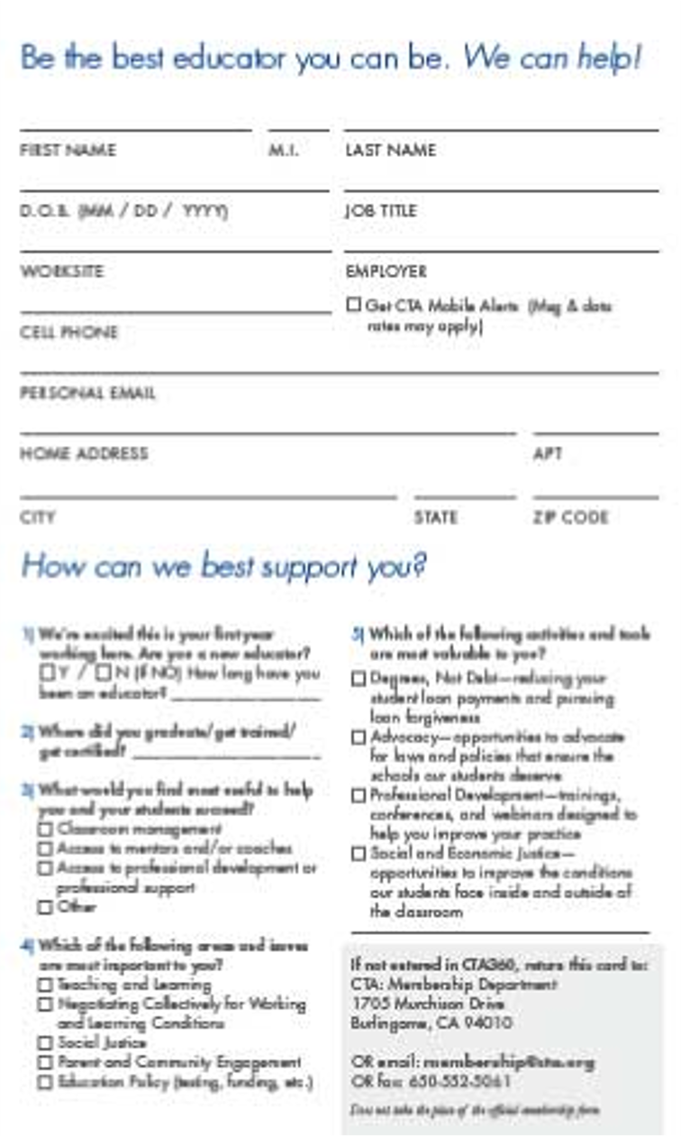
In addition to helping guide your conversation with potential new members, there is a panel of the brochure that has space to capture personal contact information and 5 questions we’d like to get answers to. The answers to these questions will help us better meet the needs of new members.
There are two ways to capture this data. Either by filing out the card and sending to CTA or by using the CTA 360 App* and completing the questionnaire on your smartphone.
CTA will send a few emails throughout the year based on an educator’s response to these questions. This information will also be available for local associations to use in making important local decisions about bargaining, membership engagement, etc.
There are also brochure versions for ESPs and Community College faculty.
This does not take the place of a CTA Membership Form. It is only to help us get to know potential members more in order to help support them with information during their first year.

Suggested Resources for the Membership Recruitment Packets
It is recommended that a Membership Recruitment Packet be provided to each local association leader who will be recruiting members. The following are suggested materials that you might find helpful to have in your membership packet:
- Leadership contact information
- List of potential members you will be contacting
- Membership form for each potential member
- Local, CTA and NEA dues amounts
- Instructions for completing the Membership Enrollment form
- Membership Recruitment Tracking Grid
- Information About potential members
- Climate Survey – Leadership Feedback form
- Participation Sign-In sheet
- Participation Feedback form
- Local association fliers or calendar of events
- CTA Member Benefits Highlights brochure for each potential member
- NEA Unlock All the Benefits of Your NEA Membership brochure for each potential member
- Three associations - One page flier – for each potential member
- Benefits of CTA Membership – One page flier – for each potential member
- CTA Conferences brochure for each potential member
Find these and more materials in the Member Engagement section of CTA’s Leaders Resource Center at www.cta.org/leaderresources.

