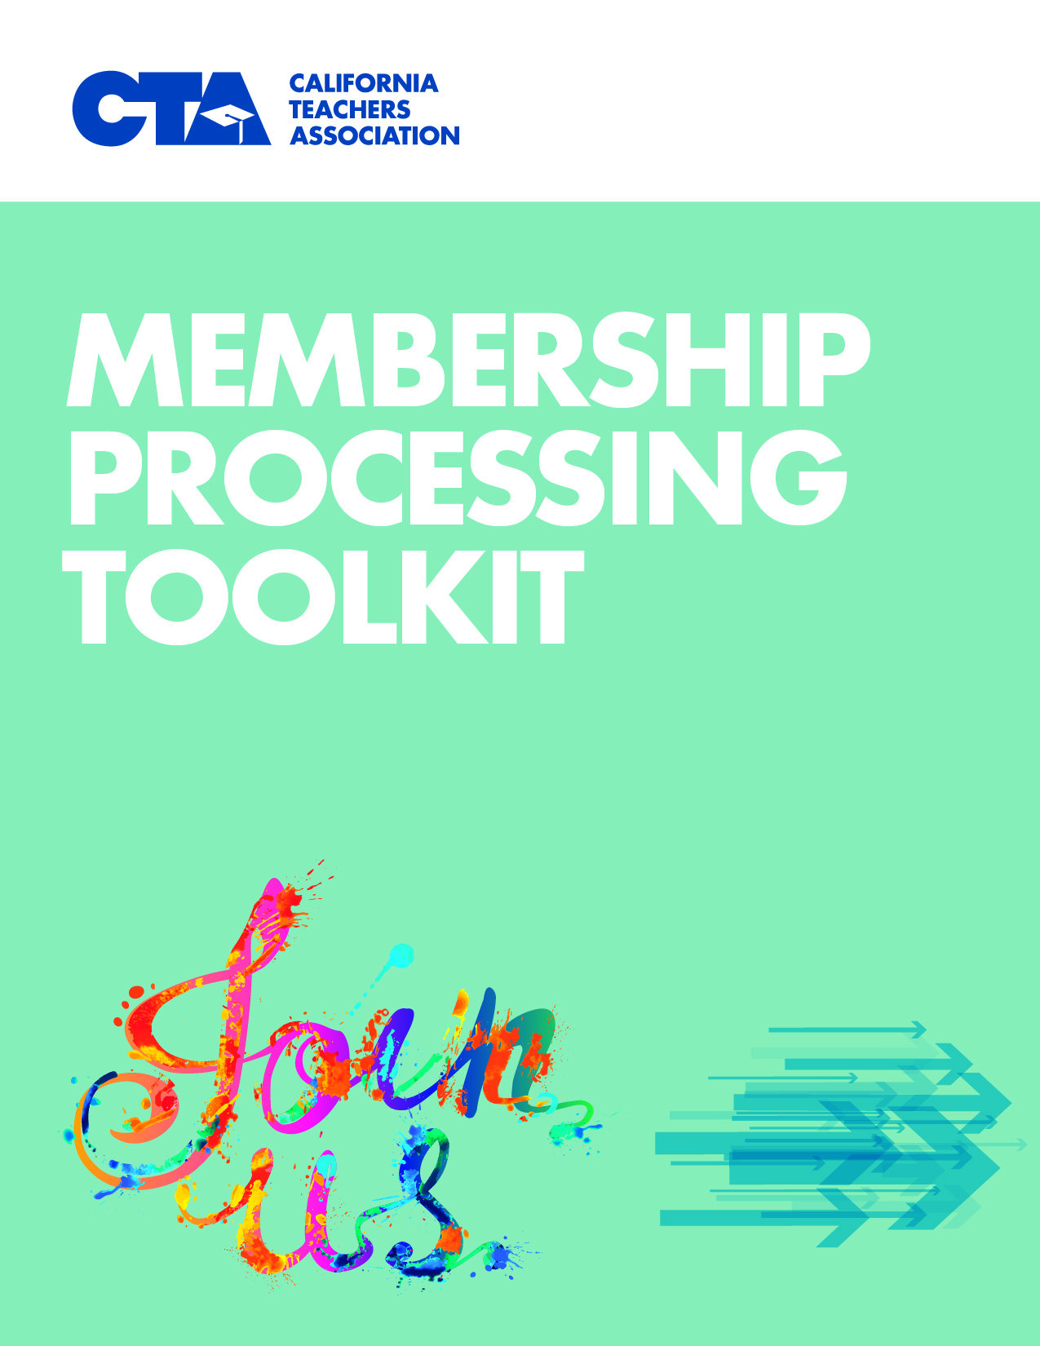

Please use these tools and guidelines as you work with new members and those who have expressed an interest in dropping membership.

Contents
- New Membership Enrollment Forms
  - Maintenance of Dues
  - Resources

- The CTA Membership Drop Process
  - What is a Valid Drop Request?
  - Steps to the Drop Process (Diagram)
  - Common drop scenarios and coordination of follow through among leaders, field staff and Membership Accounting
  - Answering Questions About the Drop Process & Maintenance of Dues
  - Sample Pre-Drop Email for Associate Staff in Response to Member
  - Sample Email with Checklist for Chapter Presidents
  - Pre-Drop Phone Script for Associate/Local Association Staff in Response to Member
  - Conversation Guidance for One-on-Ones
  - Answering Tough Questions
  - Voluntary Termination of Membership Rights and Benefits Form

- Membership Processing Tools
  - CTA 360
  - CTA 360Pro

New Membership Enrollment Forms
Ensure to use the current year version of the enrollment form. The enrollment form will be updated from year to year. There are forms for Certificated K-12, Education Support Professionals and Community College.

Maintenance of Dues
The terms and conditions of membership have been updated — specifically, a Maintenance of Dues provision which specifies that members pay dues on a year-to-year basis but may drop their dues payment obligation during an annual window period starting 60 days before and ending 30 days before their anniversary date (signature date) of enrollment. The enrollment form also contains a short member survey on page 2 which will help CTA to identify and better meet the needs and interests of members. The member’s copy of the form contains a welcome letter with helpful information for the new member.

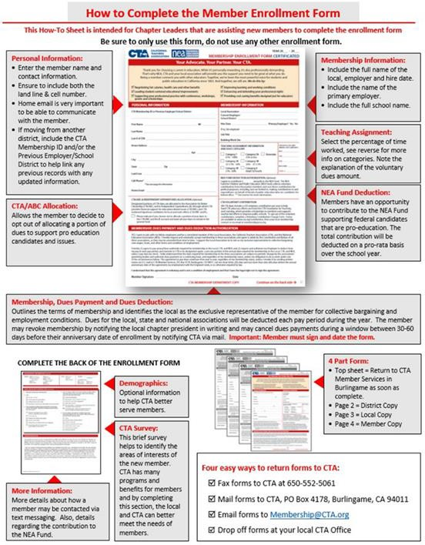
We have developed a short “How-To Guide” to assist you and your membership contacts in using the form. The How-To Guide is intended for local leaders, site reps, membership chairs and staff. The guide gives an overview of the new enrollment form and instructions/talking points on how to complete and process enrollment forms.

The most current enrollment form, How-To Guide, Membership Handbook and more resources on enrolling members can be found at the dedicated site for Membership Contacts/Chairs at www.CTA.org/Membership.

The CTA Membership Drop Process

What is a Valid Membership Drop Request?
Requests to drop local/CTA union membership must be made in writing to the Local Chapter President by the individual wanting to drop membership. The request can be made only by the individual member on his/her own behalf. The request may not be made over the phone or by email.

The written letter request to drop membership must include:
- Stated formal request to drop membership
- Member’s Full Name: First and Last
- Home Address
- Name of Local Chapter/Union
- Date
- Original signature (photocopies of signature are not acceptable)
- CTA Membership Identification number (optional)

Delivery:
Letter should be delivered to the Local Chapter President via either U.S. mail or hand delivery. (Chapters may also designate dropping them off in the local chapter office.)

Drop Process Timeframe:
Reasonable efforts should be made to process valid drop requests within 15 working days after the request is received by the Local Chapter President. (See ‘Steps to the Drop Process’)

Drop Scenarios
There are several different scenarios based on membership status and maintenance of dues. Five common scenarios have been identified along with the role and responsibility of the member, the local leader, field staff and Membership Accounting Department. You are encouraged to review these scenarios and understand your role to ensure a smooth process by all involved.

Drop Process
Scenario 1: Individual wants to drop membership.
Status: Member with no Maintenance of Dues (MoD).

Ability to Drop  Membership | Ability to Revoke  Dues | Membership Drop Protocol | Chapter Response and Process | Membership Accounting Process
At any time. | At any time. | Individual must notify chapter president in writing via US mail or hand delivery with the following information:  - Name  - Home Address  - Name of Local Chapter  - CTA ID if known  - Request to Drop Membership  - Signed and Dated | - Verify Maintenance of Dues (MoD) status. If no MoD, proceed. If MoD, see Scenario 2.  - Chapter president and/or PCS schedule follow-up within 15 days to have a conversation regarding request, resolve concerns and encourage the individual to retain membership.  - If retainment efforts are successful, memorialize the conversation in writing to the individual and confirm that their member status will remain as active.  - If retainment efforts are unsuccessful, send the following, within 15 days, to Membership Accounting (email, fax or mail):  - Member drop letter  - Drop reason – Short explanation which will be entered into member record for future reference.  - Verification of conversation – A note indicating someone talked to the individual.  - Membership Accounting will follow-up with the chapter president/PCS if these items are not included in the communication regarding the drop. | - Verify MoD status.  - Verify all membership drop documentation has been received from local.  - Send letter to district to cease deductions, cc: chapter president. Monitor district compliance.  - Send letter to individual to confirm membership drop, cessation of dues deductions. cc: chapter president and PCS.  - Update individual status in Falcon to Non-Member, Dropped.  - File all documentation.

Drop Process
Scenario 2: Individual wants to drop membership and is not within the dues revocation window to cease dues.
Status: Member with Maintenance of Dues and Active membership. Note: These members have signed a new enrollment form or commitment card. See Scenario 3 for dues authorization revocation protocol when the member is within the revocation window.

Ability to Drop Membership | Ability to Revoke Dues | Membership Drop and Dues Revocation Protocols | Chapter Response | Membership Accounting Process
At any time. | Only in window period, as determined by signature date on Commitment Card or new membership form (2018-19 or newer). | Member must follow this Two-Step Process to drop membership and revoke dues Step 1 – Drop Membership: Individual must notify chapter president in writing via US mail or hand delivery with the following information:  - Name  - Home Address  - Name of Local Chapter  - CTA ID if known  - Request to drop Membership  - Signed and Dated Step 2 – Revoke Dues Authorization:  Not eligible to revoke dues authorization until revocation window. | - Verify Maintenance of Dues (MoD) status.  - Chapter president and/or PCS schedule follow-up within 15 days to have a conversation regarding request, resolve concerns and encourage the individual to retain membership.  - Notify individual that dues deduction will continue and they need to send their request to cease dues/to revoke their dues authorization in writing to CTA Membership Accounting to be received within the opt out window. Explain MoD and the dues authorization revocation window as necessary.  - If retainment efforts are successful, memorialize the conversation in writing to the individual and confirm that their member status will remain as active  - If retainment efforts are unsuccessful, send the following to Membership Accounting (email, fax or mail):  - Membership drop letter  - Drop reason – Short explanation which will be entered into member record for future reference.  - Verification of conversation – A note indicating someone talked to the individual.  - Membership Accounting will follow- up with the chapter president/PCS if these items are not included in the communication regarding the drop. | - Verify MoD Status.  - Verify all membership drop documentation has been received from local.  - Send letter to individual to confirm drop of membership, and to notify of continuing dues deduction obligations until written dues revocation during revocation window. cc: chapter president and PCS.  - Update individual status in Falcon to Non-Member with Dues Deduction.  - File all documentation

Drop Process
Scenario 3: Individual wants to drop membership and is within the dues authorization revocation window.
Status: Member with Maintenance of Dues and Active membership. Note: These members have signed a new enrollment form or commitment card.

Ability to  Drop Membership | Ability to  Revoke Dues | Membership Drop and  Dues Revocation Protocol | Chapter Response | Membership Accounting Process
At any time. | Only in revocation window period, as determined by signature date on Commitment Card or new membership form (2018-19 or newer). | Individual must notify chapter president in writing via US mail or hand delivery with the following information:  - Name  - Home Address  - Name of Local Chapter  - CTA ID if known  - Request to drop membership  - Signed and Dated  Note: If the member is within their dues authorization revocation window when this letter is received by the local, this letter is sufficient to drop membership and revoke dues authorization at the same time. | - Verify Maintenance of Dues (MoD) status.  - Chapter president and/or PCS schedule follow-up within 15 days to have a conversation regarding request, resolve concerns and encourage the individual to retain membership.  - If retainment efforts are successful, memorialize the conversation in writing to the individual and confirm that their member status will remain as active  - If retainment meeting is unsuccessful, send member drop letter, drop reason and verification of conversation to Membership Accounting within 15 days (email, fax, or mail):  - Member drop letter  - Drop reason – Short explanation which will be entered into member record for future reference.  - Verification of conversation – A Note indicating someone talked to the individual.  - Membership Accounting will follow-up with the chapter president/PCS if these items are not included in the  communication regarding the drop. | - Verify MoD Status, dues authorization revocation window.  - Verify all drop documentation has been received from local.  - Send letter to district to cease deductions, cc: chapter president. Monitor district compliance.  - Once all documentation is verified, send letter to individual to confirm drop of membership, cessation of dues deduction. cc: chapter president and PCS.  - Update individual status in Falcon to Non-Member.  - File all documentation.

Drop Process
Scenario 4: Individual has already dropped membership and is now within the dues authorization revocation window.
Status: Non-member with Dues Deduction. See Scenario 2.

Ability to Drop Membership | Ability to Revoke Dues | Dues Revocation Protocol | No Chapter Response | Membership Accounting Process
NA | Only in revocation window period, as determined by signature date on Commitment Card or new membership form (2018-19 or newer). | Revoke Dues Authorization:  Individual must send written notice to revoke their dues authorization or use term “drop membership” or similar via mail to CTA Membership Accounting to be received during the individual’s specific revocation window. | No chapter response required in this scenario.  The chapter has already had a conversation with the individual when the request was made to drop membership. Now the individual is within their revocation window and would send a letter directly to Membership Accounting stating their intent to now revoke their dues authorization. | - Validate dues revocation window.  - Send letter to district to cease deductions. cc chapter president. Monitor district compliance.  - Send letter to individual to confirm dues cessation. cc: chapter president and PCS.  - Update individual status in Falcon to Non- Member, Dropped.  - File all documentation.

Drop Process
Scenario 5: Individual requests to drop membership and/or revoke dues authorization and is within the dues authorization revocation window. Individual sends request letter directly to CTA Membership Accounting.
Status: Member with Maintenance of Dues.

Ability to  Drop Membership | Ability to  Revoke Dues | Membership Drop & Dues Revocation Protocol | CTA & Chapter Response | Membership Accounting P rocess
At any time. | Only in revocation window period, as determined by signature date on Commitment Card or new membership form (2018-  19 or newer). | If an individual mails or delivers a letter to CTA Membership Accounting directly, and is within the dues authorization revocation window, the request will not be immediately processed, and is pending member notice to local chapter and local chapter verification.  The individual must initiate the notice with their chapter president.  Request must include:  - Name  - Home Address  - Name of Local Chapter  - CTA ID if known  - Request to drop membership and/or dues revocation  - Signed and Dated  Note: If the member is within their dues authorization revocation window when this letter is received by the chapter president, this letter is sufficient to drop membership and revoke dues authorization at the same time. | CTA Membership Accounting Response:  - Verify Maintenance of Dues (MoD) status.  - CTA Membership Accounting to send a letter to individual stating that membership must be dropped via the chapter president and explain the process. cc: chapter president and PCS.  - Membership Accounting emails chapter president and PCS indicating that a membership drop and/or dues authorization revocation request has been received and outline next steps for the local.  - Within 15 days, chapter president and/or PCS contact the individual to have a conversation regarding request, resolve concerns and encourage the individual to retain membership.  - If retainment efforts are successful, memorialize the conversation in writing to the individual and confirm that their member status will remain as active.  - If retainment efforts are unsuccessful (including if member is unresponsive), the individual still must submit a letter indicating their desire to drop membership. Once this letter is received by the chapter president, communicate in writing to CTA Membership Accounting the results of the conversation and the drop reason and send a copy of the drop request. If the drop request is dated and signed within the dues authorization revocation window, this also satisfies the requirement to  revoke dues. | - Verify MoD Status and dues authorization revocation window.  - Verify all drop documentation has been received from local.  - Send letter to district to cease deductions. cc: chapter president. Monitor district compliance.  - Send letter to individual to confirm drop of membership and cessation of dues deduction cc: chapter president and PCS. If outside of dues authorization revocation window, communicate this via writing to the individual.  - Update individual status in Falcon to Non-Member.  - File all documentation.

15 Working-Day Processing Timeline Begins:
Notification to Local President and contact logged at CTA office, and the 15 working- day processing deadline begins.
Valid Drop Request Delivered:
Member provides a valid drop request to the Local Chapter President via U.S. mail or hand-delivery or by dropping it at local Chapter office if designated by the Chapter. For a drop request to be valid and processed, it must include a stated formal request to
drop membership, member’s full name, home address, name of local, date, and
original signature.

General Steps in the Drop Process
Initial Interaction:
Member notifies RRC/UniServ/CTA Headquarters/Site Representative via phone, text, in person, or via email that they would like to drop their CTA membership. Whoever receives the call, text or email confirms membership and maintenance of dues anniversary date if applicable. The member is informed that a drop request must be sent by U.S. mail or hand- delivered to the Local President or dropped at local chapter office if designated by the Chapter. Notify Local Chapter and staff that a member inquired about dropping.

Have Organizing Conversation with Member:
Identify the most compelling person to hold a one-on-one conversation with the member. Conversation can be done by any leader or member. The benefits of collective bargaining and advocacy should be discussed, and all the member benefits that will be lost should be shared. Utilize voluntary termination or recommitment forms in asking the member to reconsider. Be sure to listen, try to directly address the member’s concerns, and document the reasons.

See the Drop Scenarios for specific steps in the process.
Completing the Request:
The member will either agree to rescind the request to drop or will want to go through with it. Either way, the ultimate decision to stay or leave the union should then be shared with the RRC, UniServ and CTA Membership Department. In the case of a drop, send the drop letter, drop reason, and verification of conversation to Membership Accounting for final system updates and formal confirmation back to the individual and district.

Answering Questions About the Drop Process and Maintenance of Dues

How do I drop my membership?
We encourage you to maintain your membership. Our effectiveness in bargaining fair and just salaries, benefits, and working conditions is directly related to member support and the power we have in our collective voice. Increasing funding to public schools, reducing class sizes, and ensuring that professional rights such as due process and permanent status are protected are direct results of the important work we have been able to accomplish because of a united CTA membership.

If you still decide you’d like to drop your union membership, you just need to put your request in writing. The letter will need to be mailed or hand-delivered to your Local Chapter President. The letter must include a stated formal request to drop membership, your full name, home address, local chapter name, date and original signature. If you happen to have your membership ID number, that would be appreciated. We have many members with the same or similar names, and we need to be sure that we are responding to a request from the correct member.

When can I drop my membership?
Members can drop their membership at any time. You just need to put your request in writing. The letter will need to be mailed or hand-delivered to your Local Chapter President. The letter must include a stated formal request to drop membership, your full name, home address, local chapter name, date and original signature. If you happen to have your membership ID number, that would be appreciated.

Does this ruling mean I can I drop my membership and not pay dues?
You could, but that would be exactly what the forces behind this court case want. The corporate special interests, billionaires and politicians want to weaken the ability of working people to come together in unions to negotiate on behalf of their members and, in our case, to stand up for our students and for public education. It’s part of a broader scheme to rig the system against working people.

Would I get the same benefits if I did drop my membership?
No. You immediately lose any voice in your union and the right to vote on the contract. The union would still negotiate your salary, benefits and working conditions, but you would have no say in those discussions. You will also be ineligible for all the benefits that come with membership, including a
$1 million personal liability policy, legal services, access to teacher-led professional development, and membership discounts on insurance, entertainment, and travel.

What is this new maintenance of dues?
With the new enrollment form, when an educator joins CTA, they also agree to pay continuous annual dues. This common practice allows the union to provide ongoing support to its members and budget accordingly.

When I drop my membership, are my dues automatically stopped?
This depends on if you have signed a membership form or commitment card that includes the maintenance of dues provision. If there is no maintenance of dues provision, then yes, your dues automatically stop. If you agreed to maintain dues annually, then you must also notify the California Teachers Association to stop dues payments. This can be done not less than 30 days and not more than 60 days before the member’s annual anniversary date by mailing a written notice to CTA Member
Services in Burlingame. The written notice must include the member’s full name, address, local chapter
name, authentic signature and date.

So, I dropped my membership — how do I stop paying continuous annual dues?
This can be done not less than 30 days and not more than 60 days before the member’s annual anniversary date by mailing a written notice to CTA Member Services, P.O. Box 4178, Burlingame, CA 94011. The written notice must include the member’s full name, address, local chapter name, authentic signature and date.

How do I know my anniversary date?
Your anniversary date is the date you joined CTA. You can get that information from your local chapter or CTA Member Services.

What does not less than 30 days and not more than 60 days before my anniversary date mean?
It means any member who has dropped membership can also stop their continuous annual dues payment in a 30-day window about a month before their anniversary date. For example, if you joined CTA on August 15, you can revoke your annual dues any time between June 16 and July 16.

Why do I have to drop membership and dues payments separately?
The maintenance of dues provision is a common practice used in many unions, many organizations and service agreements, and allows the union to provide ongoing support to its members and budget accordingly. It works similar to a gym membership. You join for the entire year and agree to pay for the entire year. You can choose to stop going, but you are obligated to pay for the entire term of the membership contract. Many unions only have a short window of time, such as a five-day window, to revoke dues for the following year. CTA gives members 30 days.

Sample Pre-Drop Email for Associate Staff in Response to Member

Dear :

I received your inquiry regarding changing your membership status. I am copying your local Association President, , and CTA Primary Contact Staff, , on this email so they can provide support. Logistically, any request to change membership status needs to be made in writing and hand- delivered or mailed to your chapter president or to your local Association office. The letter must include a stated formal request to change membership status, your full name, home address, local chapter name, date and your original signature.

We encourage you to maintain your membership. Our effectiveness in bargaining fair and just salaries, benefits, and working conditions is directly related to member support and the power we have in our collective voice. Increasing funding to public schools, reducing class sizes, improving school safety, and ensuring that professional rights such as due process and permanent status are protected are direct results of the important work we have been able to accomplish because of a united CTA membership.

Union membership provides many critical benefits for you and your colleagues. Only members can have input and vote on the local contract regarding learning and working conditions, salary, health care and other benefits. Members have access to an experienced attorney as needed when issues arise around discipline, credentialing questions, complaints, and layoffs. Through various local trainings and CTA conferences, members have access to teacher-led professional development, as well as scholarships for continuing their education. Members also receive $1,000,000 educators’ liability insurance, retirement assistance, and numerous discounts on travel, restaurants and entertainment.

Your voice and membership are important. Please reach out to any of us if you have further questions.
(Local Contact ) Log the inquiry.

If you receive an email at the local level, please feel free to use any of the above language when responding to the email. We do encourage you to localize the information.

Sample Email with Checklist for Chapter Presidents

Greetings, President,

You have had a member request to drop membership.

The member is INSERT Name and Membership #
Home address
Personal Email
Home Phone
Cell Phone
If applicable: This member has Maintenance of Dues. INSERT Anniversary Date.

We have referred him/her to the drop process, which requires signed notification to you. This an outline of necessary steps to take now and some ideas on how to encourage the person to remain a member:

- Contact your Primary Contact Staff immediately (cc’d on this email).
- If you don’t know the member, reach out to the person’s site rep to see if there was anything
that triggered the drop and what can be done to reverse it.
- Set up a one-on-one meeting (with you, or the rep, or another member, or your PCS) with the member to demonstrate the power of staying in the union and discourage the drop.
- Send/bring member information about benefits of union (CTA Leader Resources).
- Have the person sign the “Voluntary Termination of Benefits” form if you cannot convince them to remain a member.
- If you do convince them to remain a member, have them sign the new Membership Form.
- If member does decide to drop, try to ascertain the reason(s) and report them back to your PCS.
- Once a valid drop request has been received, you have 15 working days to process the valid drop request if you were not able to persuade the person to retain membership.

This email contains multiple resources for you to reach out to your members. The timelines to respond are short, so meeting with the member quickly is critical. If you have any questions, please reach out to your PCS right away.

Pre-Drop Phone Script for Associate Staff/Local Association Staff in Response to Member
Thanks for reaching out to us. I’m sorry to hear that you are looking to drop your membership.

Get Name from caller and look up in Falcon. Validate the caller’s Home Address, Home Email, Home Phone and Cell Phone and update Falcon as necessary. Confirm if they have a maintenance of dues agreement. If they do, also note the anniversary date.

You know, our ability to bargain fair and just salaries, benefits, and working condition is directly related to the power we have as a collective voice. That’s why your membership is important. Only members can have input and vote on the local contract. Through various local trainings and CTA conferences, members have access to teacher-led professional development, as well as scholarships for continuing your education. Members have access to an experienced attorney if issues arise around discipline, credentialing or layoffs. Members also receive $1 million educators’ liability insurance, retirement assistance, and numerous discounts on travel and entertainment.

Would you like (Association President) or (Primary Contact Staff) to give you a call to talk further?

  - If yes, end the call and give the message to President/staff. Log the inquiry.

  - If no/they insist upon dropping membership, let them know they need to put the request in writing and mail or drop off at the Association office (assuming there is an office). Provide the mailing address. Email president and staff to let them know. Log the inquiry.

The letter will need to be mailed or hand-delivered to your Local Chapter President. The letter must include a stated formal request to drop membership, your full name, home address, local chapter name, date and original signature.

Conversation Guidance for One-on-Ones
With the Janus v. AFSCME decision, CTA is at a critical point in our history. Our success in staving off this unprecedented attack on our Association and all it does for our members is dependent on personalizing the experience of being part of the Association. When members want to drop their membership, it is
critical that we find the right person to talk to them about their decision. It’s easy to say no to a nameless/faceless person. It’s hard to let down those you care about.

LEA/CTA/NEA:
Use the Voluntary Termination of Membership Rights and Benefits Form and the “Member vs. Nonmember” flyer to guide the member through all that they lose when they terminate their CTA membership. Use your personal knowledge of the person to highlight the parts of the form that would be most persuasive to them. Stress throughout the conversation that being part of the union is how we fight together for a better profession, wages, benefits, and working conditions.

Listen to concerns:
Listen to the concerns of the member. Be patient and kind. Do NOT attack or belittle the member. Try to pinpoint why the member is dropping. Use the “Answering the Tough Questions” Guide to counter the various reasons why they want to drop their membership.

Conversation Style:
It is important to be yourself and keep your conversations earnest. The “Feel, Felt, Found” conversation is an effective one-to-one conversational frame for dealing with objections or hesitation on the part of potential members. If you approach a potential member with an invitation to join your local association and are met with “I really don’t see any reason to join,” use the following conversational frame to keep the conversation going:

FEEL | “I know how you feel.”  “Hey, I get it. I never gave unions much thought either. I guess I thought I could take  care of myself in just about any situation.”
FELT | “I have felt the same way myself.”  “In fact, I was pretty resentful when a union rep convinced the principal that I wasn’t  experienced enough to handle an upper-grade class.”
FOUND | “But I found that…”  “It turned out, though, that the union really helped when I had a payroll dispute with the district. When the district refused to place me on the correct salary step, the union hired a lawyer and the district ended up owing me a lot of money for back  pay.”

Issues/Agitation:
Get at biographical information (if you don’t know the member well)
  - How long has the member been there?
  - How did the member end up there?

Also get at issues/concerns
  - What needs to be improved in our school/district?
  - How can we work together to improve it?
  - What makes working here long term most difficult?
  - If you could change any 3 things, what would they be?

Look for opportunities to engage the member into action.

What to do if you are successful/unsuccessful:

Successful:
If you’re successful, tell the member that you want to continue to talk about how we can improve the Association. Offer yourself as a resource and a sounding board. Make sure to follow up several more times with the member and keep them informed on ways they can get involved when opportunities arise (e.g., encourage them to run for office, put their name into committee they are interested in, etc.).

Unsuccessful:
Make sure they initial and sign the Voluntary Termination of Membership Rights and Benefits Form (if they refuse to initial and sign, do it yourself as proof you shared the info). If they have their membership termination letter, collect it and get it to your chapter president. Ask the member to think about their decision and offer yourself as a resource. Let them know their request will be completed within 15 working days of receiving the valid drop request. If the member has maintenance of dues, inform them of the process for revoking continuous annual dues.

Answering the Tough Questions
See CTA’s Guide to Answering the Tough Questions Here

Date:
Voluntary Termination of Membership Rights and Benefits
After speaking with representatives of my local chapter and the California Teachers Association, I understand that I have elected to forfeit the following Local/CTA/NEA benefits by requesting my membership be terminated:

Freedom to be a part of California’s leading education organization, established in 1863, fighting for a better future and the public education all our students deserve through our ability to come together to make improvements for educators and our students.

Right to vote on the local collectively bargained contract regarding learning and working conditions, fair salary, health care, and other benefits; as well as the right to vote in all union elections.

Access to educator-led professional development and leadership training opportunities sponsored by CTA at the local, regional and statewide levels. This includes conferences such as Good Teaching Conference, Equity and Human Rights, The Issues Conference, and GLBT Issues, as well as scholarships to continue your education.

Access to legal and professional representation and advice, including due process rights; wage and hours issues; certification, classification and credential issues; discrimination charges; and retirement issues.

Access to various CTA Member Benefits, including:
    - $1 million in work-related liability insurance.
    - NEA Life Insurance Coverage.
    - CTA Disaster Relief Fund grants should your home or school be damaged in disaster
    - CTA Death & Dismemberment Insurance
    - Exclusive Discounted CTA & NEA Member Benefits programs:
      - Auto & home insurance
      - Voluntary life & disability insurance
      - Investment & financial resources
      - Travel, restaurant & entertainment discounts

I understand that my decision to terminate my membership from CTA may result in reduction in bargaining strength, which ultimately may affect my current wages, hours and working conditions. In addition, it may be detrimental to my future wages, hours, working conditions and benefits bargained by CTA.

Terminating Member’s Signature Print Name

Representative: (Print Name:)

Membership Processing Tools

CTA 360
CTA 360 is a free mobile app available to local leaders including Presidents, Vice Presidents, Membership Contacts, Site Reps, etc. CTA 360 is directly linked to CTA’s Association Management System and allows leaders to quickly access their local’s data (member contact info, emails, work location, etc.) from their mobile device. The app also allows local representatives to sign up new members, update member information, view membership analytics, and more! This app is available for iOS and Android devices.

  - Learn more and get trained – Visit www.CTA.org/Membership for details and to get started.
CTA 360Pro
CTA 360Pro is the desktop/laptop access point for local leaders to access CTA’s Association Management System. This access is similar to the CTA 360 app but with additional reporting functionality. This is a dedicated website that is accessible from any Internet browser.

  - Learn more and get trained – Visit www.CTA.org/Membership for details and to get started.
Membership Chairperson Resources
Membership processing is a continuous job to maintain accurate membership information for the local chapter and CTA. A local chapter’s Membership Contact assists the local with these responsibilities:

- Work with site representatives in communicating with, recruiting, and maintaining members
- Work with site representatives in distributing membership materials, such as membership cards and enrollment forms
- Promote local, CTA & NEA member benefits
- Facilitate in membership engagement activities
- Help communication between local, CTA, and school district to resolve membership issues
Visit www.CTA.org/Membership to learn more about your role.

