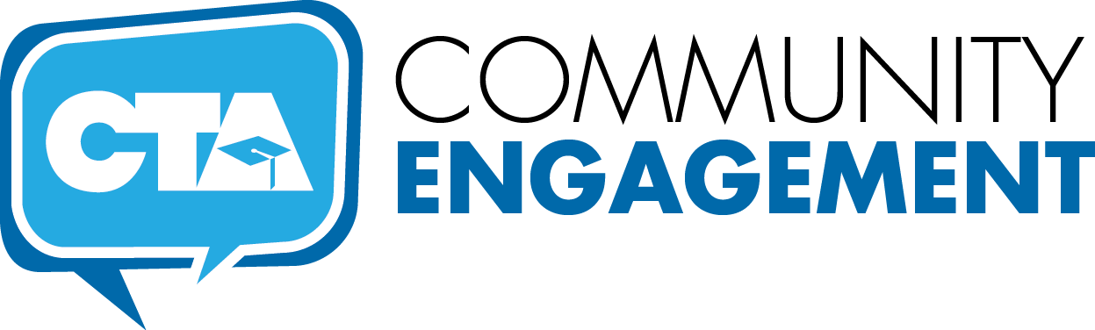

THE TOOLKIT
7 Steps
Successful Community Engagement

B
uilding vibrant, ongoing and mutually beneficial partnerships with parents, students, other unions and community organizations is essential for CTA’s long-term success. We know that many organizations share our goals for quality public schools and recognize public education as the cornerstone of building strong local communities. That’s one reason community engagement is such an important part of CTA’s Strategic Plan, “Our Union, Our Future.” Often community engagement will develop organically, but meaningful and sustainable partnerships takes time, planning and a little know-how. Once you master a few easy steps, though, you (and your local association) will be well on your way to raising the profile of your local chapter and building support for neighborhood schools and colleges.
So let’s get started…

Build a Team
Listen to Your People
Create a Compelling Vision
Develop a Plan
Conduct a Power
Analysis and Community
Mapping
Evaluation and Key Learnings
Execute the Plan
7 Steps to Creating Successful Community Engagement Teams

Step 1. Listen to Your People
Listening is the most important aspect of creating a relevant and member-centered Community Engagement Team (CET). Strategic, intentional listening is a skill developed by practicing. This step is essential to developing a meaningful plan that your team will want to commit to achieving. When done well, it can enable teams to perform expertly in a very short time frame.
RESOURCES
Seven Factors of a Listening Organization
Skills for Organizational Listening (UTS)
- From “Creating an ‘Architecture of Listening’ in Organizations” by Dr. Jim Macnamara
  - Listening Practices for Chapters (Page 10)
  - Seven Factors of a Listening Organization (Page 7)
Building Better Listening Skills (NEA)
Accessing Your Listening Ability (I-CANS)
Step 2. Build a Team
The key to Building a successful Community Engagement Team starts with finding the right people. CET members should be educational leaders at their sites and connected to the communities in which they seek to work, and have influence not only amongst their peers but with parents and other local stakeholders.
RESOURCES
Steps to Building an Effective Team, Characteristics of an Effective Team, Building a Team That Can Make Change Happen and 13 Ways to Be a Better Community Engagement Team Leader
WATCH: The Difference between Winning and Succeeding, John Wooden
TED Interview, 2001
READ: The Four Traits of Healthy Teams, Patrick Lencioni
IESE University interview, November 2011

Step 3. Create a Compelling Vision
Each community is unique, when beginning a Community Engagement Team project, the chief concern should be to connect in a way that is meaningful in the community you will be working with. The question should be, “What wants to happen here?” Chapter and community surveys may be of some help in determining not only the highest community needs, but the matching of the CET team’s goals and skillsets with meaningful action in the community.
RESOURCES
Developing a Vision and Strategy, Characteristics of an Effective Visions and Listening Practices for Chapters
WATCH: Start with Why – Simon Sinek
TED Talk, September 2009
READ: “What Leading with Vision Really Means”
Fast Company November 2012
Step 4. Conduct a Power Analysis and Community Mapping
As the local plan is being developed and refined, one element of ensuring success of the plan is to conduct a community mapping and power analysis. By mapping the community, the CET will be able to identify resources and community assets, as well as develop a list of key players, contacts and social networks, which can help prioritize and focus the work of the CET. The Power Analysis examines current power relationships and determines who and what are needed to execute the plan, by formulating a strategy to reach the target.
RESOURCES
8 Steps for Strategic Power Analysis & Community Mapping
FORM: Mapping the Actors

Step 5. Develop a Plan
Each plan will be different and customized to the specific needs, goals and desires of the community in question. Once the Community Engagement Team is established, time should be spent listening to staff and community members to identify the specific goals of their community and answer the questions: What wants to happen here? Who do we need? What do we need to be successful? A final executable plan will include answers to the following questions:
- Who is responsible for each aspect of the plan?
- What are the most effective activities and actions to activate our power and effect the change we wish to see?
- Who will we work with to achieve the desired outcome?
- What is the realistic time frame necessary to carry out the specific action, activity and campaign?
- What resources, time, people and money will be needed to carry out the plan?
RESOURCES
What is an Action Plan? and Empowering People to Effect Change
FORMS: Checklist for Developing an Action Plan and Action Plan Template
Step 6. Execute the Plan
Once the plan has been created, goals established and resources identified, the plan must be tactically executed by doing the work to achieve the desired outcome. Action planning tools for organizing events, mobilizing events, and holding strategic meetings are available in the Community Engagement toolkit. The actual objective of a campaign — or, as it is often called in organizing jargon, the “win” — is often the most visible part of the organizing process and is probably the most commonly evaluated. Related to the development of power, in that achieving the outcome of a campaign is often associated with developing the power necessary to win the campaign, it is usually fairly easy to objectively identify whether or not an organization has reached its campaign objective.
RESOURCES
Translating the Idea of Change Into Action
READ: “Leading Change — Leadership, Organizing and Social Movements”
by Marshall Ganz

Step 7. Evaluation and Key Learnings
Evaluation is about incorporating ongoing reflection and learning into a CET’s work. Much of the CET’s organizing work in particular is about learning as you go — learning about what kinds of strategies and tactics work when, where, and under what conditions, and paying close attention to process and how leaders grow and develop. Key learnings should be continually discussed and reviewed as to how the process can be improved moving forward.
RESOURCES
Goal Attainment Report
FORMS: Community Organizing Project Evaluation, Individual CET Reflection Questions and Evaluation Plan Checklist

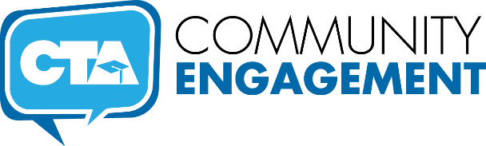
RESOURCE for STEP 1.
Listen to Your People

Organizational Listening
From the Toolkit
7 Steps: Successful Community Engagement

Seven Factors of a Listening Organization
Adapted from “Creating an ‘Architecture of Listening’ in Organizations” by Dr. Jim Macnamara

- Recognition of others as people or groups with legitimate rights to speak and be treated with respect.

- Acknowledgment, which is sometimes assumed to be part of recognition of others or seen as part of response; but quick and specific acknowledgment is an important signal to those who speak that what they say has been heard and is receiving attention (the next step).

- Giving attention to others. Beyond an initial acknowledgment, listening to others requires cognitive focus as well as some level of empathy (affective engagement or emotional intelligence).

- Interpreting what others say as fairly and receptively as possible — not glossing over, misinterpreting, rejecting because of prejudices or information processing barriers, or automatically resorting to persuasion to try to “talk the speaker out of” their viewpoint, position or concern — all of which happen all too often.

- Trying as far as possible to achieve understanding of others’ views, perspectives, and feelings.

- Considering what others say. Considering the views, opinions, comments, and concerns of others is specifically listed as the sixth stage within the seven factors of organizational listening, as consideration should follow giving attention, interpreting, and gaining understanding.

- Responding in an appropriate way. Beyond initial acknowledgment, a more substantial response is usually required after consideration of another’s expression of voice.

RESOURCE for STEP 2.
Building a Team

Tips for Building Effective Teams
From the Toolkit
7 Steps: Successful Community Engagement

WATCH: The Difference Between Winning and Succeeding, John Wooden, TED Interview, 2001
READ: The Four Traits of Healthy Teams, Patrick Lencioni, IESE University interview, November 2011

Steps to Building an Effective Team
Adapted from the University of California, Berkeley – Guide to Managing Human Resources, 2015
The first rule of team building is an obvious one: To lead a team effectively, you must first establish your leadership with each team member. Remember that the most effective team leaders build their relationships of trust and loyalty, rather than fear or the power of their positions.
- Consider each team member’s ideas as valuable. Remember that there is no such thing as a stupid idea.
- Be aware of members’ unspoken feelings. Set an example to team members by being open with all individuals and sensitive to their moods and feelings.
- Act as a harmonizing influence. Look for chances to mediate and resolve minor disputes; point continually toward the team’s higher goals.
- Be clear when communicating. Be careful to clarify intention and goals.
- Encourage trust and cooperation among members on your team. Remember that the relationships team members establish among themselves are every bit as important as those you establish with them. As the team begins to take shape, pay close attention to the ways in which team members work together and take steps to improve communication, cooperation, trust, and respect in those relationships.
- Encourage team members to share information. Emphasize the importance of each team member’s contribution and demonstrate how all of their jobs operate together to move the entire team closer to its goal.
- Delegate problem-solving tasks to the team. Let the team work on creative solutions together.
- Facilitate communication. Remember that communication is the single most important factor in successful teamwork. Facilitating communication does not mean holding meetings all the time. Instead, it means setting an example by remaining open to suggestions and concerns, by asking questions and offering help, and by doing everything you can to avoid confusion in your own communication.
- Establish team values and goals; evaluate team performance. Be sure to talk with members about the progress they are making toward established goals so that employees get a sense both of their success and of the challenges that lie ahead. Address teamwork in performance standards. Discuss with your team:
- What do we really care about in performing our job?
- What does the word success mean to this team?
- What actions can we take to live up to our stated values?
- Make sure that you have a clear idea of what you need to accomplish; that you know what your standards for success are going to be; that you have established clear time frames; and that team members understand their responsibilities.
- Use consensus. Set objectives, solve problems, and plan for action. While it takes much longer to establish consensus, this method ultimately provides better decisions and greater productivity because it secures every team member’s commitment to all phases of the work.
- Set ground rules for the team. These are the norms that you and the team establish to ensure efficiency and success. They can be simple requests (Team members are to be punctual for meetings) or general guidelines (Every team member has the right to offer ideas and suggestions), but you should make sure that the team creates these ground rules by consensus and commits to them, both as a group and as individuals.
- Establish a method for arriving at a consensus. You may want to conduct open debate about the pros and cons of proposals, or establish research committees to investigate issues and deliver reports.
- Encourage listening and brainstorming. As a team leader, your first priority in creating consensus is to stimulate debate. Remember that participants are often afraid to disagree with one another and that this fear can lead your team to make mediocre decisions. When you encourage debate, you inspire creativity, and that’s how you’ll spur your team on to better results.
- Establish the parameters of consensus-building sessions. Be sensitive to the frustration that can mount when the team is not achieving consensus. At the outset of your meeting, establish time limits, and work with the team to achieve consensus within those parameters. Watch out for false consensus; if an agreement is struck too quickly, be careful to probe individual team members to discover their real feelings about the proposed solution.

Characteristics of an effective team
Sources: The Human Side of Enterprise, by Douglas McGregor; The Wisdom of Teams, by Katzenbach and Smith

- There is a clear unity of purpose. There is free discussion of the objectives until members can commit themselves to them; the objectives are meaningful to each group member.
- The group is self-conscious about its own operations. The group has taken time to explicitly discuss group process — how the group will function to achieve its objectives. The group has a clear, explicit, and mutually agreed-upon approach: mechanics, norms, expectations, rules, etc. Frequently, it will stop to examine how well it is doing or what may be interfering with its operation. Whatever the problem may be, it gets open discussion, and a solution is found.

- The group has set clear and demanding performance goals for itself and has translated these performance goals into well-defined concrete milestones against which it measures itself. The group defines and achieves a continuous series of “small wins” along the way to larger goals.

- The atmosphere tends to be informal, comfortable, relaxed. There are no obvious tensions, a working atmosphere in which people are involved and interested.

- There is a lot of discussion in which virtually everyone participates, but it remains pertinent to the purpose of the group. If discussion gets off track, someone will bring it back in short order. The members listen to one another. Every idea is given a hearing. People are not afraid of being foolish by putting forth a creative thought even if it seems extreme.

- People are free in expressing their feelings as well as their ideas.

- There is disagreement, and this is viewed as good. Disagreements are not suppressed or overridden by premature group action. The reasons are carefully examined, and the group seeks to resolve them rather than dominate the dissenter. Dissenters are not trying to dominate the group; they have a genuine difference of opinion. If there are basic disagreements that cannot be resolved, the group figures out a way to live with them without letting them block its efforts.

- Most decisions are made at a point where there is general agreement. However, those who disagree with the general agreement of the group do not keep their opposition private and let an apparent consensus mask their disagreement. The group does not accept a simple majority as a proper basis for action.

- Each individual carries his or her own weight, meeting or exceeding the expectations of other group members. Each individual is respectful of the mechanics of the group: arriving on time, coming to meetings prepared, completing agreed-upon tasks on time, etc. When action is taken, clear assignments are made (who, what, when) and willingly accepted and completed by each group member.

- Criticism is frequent, frank and relatively comfortable. The criticism has a constructive flavor — oriented toward removing an obstacle that faces the group.

- The leadership of the group shifts from time to time. The issue is not who controls, but how to get the job done.

Building a Team That Can Make Change Happen
Leading Change, John P. Kotter, 2012

Find the right people
- With strong position power, broad expertise, and high credibility
- With leadership and management skills, especially the former
Create trust
- Through carefully planned off-site events
- With lots of talk and joint activities
Develop a common goal
- Sensible to the head
- Appealing to the heart

13 Ways to Be a Better Community

Engagement Team (CET) Leader

Your chapter has created a Community Engagement Team, and you are the leader. While this role within the Association is critical to chapter efforts to engage their community and will often be quite rewarding, it won’t always be easy. Having a leadership role means you need to get your own work done while leading others, and often it means making tough decisions.
It can be easy to get caught up in your responsibilities, but if you want to be a good leader, you need to take time to consider how you can improve. As a CET leader, if you can be your best self, your team will perform at the highest levels.
In conversations with CTA Chapter leaders, here’s what they say are 13 ways to be a better leader:
- Be a teacher.
As a teacher, you understand the importance of setting goals and objectives daily for your class. As a CET leader, that is also true. Creating clear goals, expectations and roles will ensure that the work of your committee is understood. The ability to communicate your ideas and allow input from your team will help build a shared vision of the work you will do together.

- Be a coach, not a parent.
Remember, you are not your team members’ parent — you’re their leader. As a leader, your focus should be on coaching your team members and working with them to instruct, practice and learn together as you engage with the community around your shared work.
“To be an effective leader, you need to start at the heart of the company: your employees. I firmly believe happy and engaged employees do great things. Invest in them, and provide a clear picture of where the company stands and where it is headed. The critical first step is creating a vibrant company culture where people are motivated, and where collaboration is fostered and healthy lifestyles are encouraged.” —Bruce Cazenave, CEO, Nautilus
- Admit when you’re wrong.
“It may be counterintuitive, but admitting that you’re wrong doesn’t have to be a sign of weakness, even in the often-competitive atmosphere of today’s workplace. In my experience, it actually makes you a stronger leader. Practice advertising, rather than hiding, your mistakes. People trust you more when you’re open about your imperfections.” —Alan C. Fox, president, ACF Property Management [30 Inspiring Leadership Quotes ]
- Communicate better.
“Listen and observe more. Talk and multitask less. We all give clues as to what is going on internally on a regular basis. Those clues give great insight into how to communicate with your employees more effectively. Focus as much on “how they say it” as what they say, and observe nonverbal communication, tonal and pitch changes, and changes in regular communication patterns, to see potential issues before they arise.” —Matt Eventoff, owner, Princeton Public Speaking
- Sing the praises of your team.
One of the best traits of a good leader is to be able to build excitement among team members about the project they are working on, whether it is organizing a community event sponsorship or an ongoing grand project. Take every opportunity to praise the efforts that team members make toward achieving your goals. Team leaders and members need to be able to articulate clearly why the Community Engagement efforts they are working on are so important.
- Recognize your team member’s strengths, give feedback in private.
“Get good at spotting the strengths of others, including your direct reports, peers and your boss. Research indicates that paying attention to the strengths of others is a critical element in developing others to be more successful, as well as building effective partnering relationships.” —Dr. Karissa Thacker, management psychologist
- Lead with love.
“So many managerial tips focus on tactics. If more leaders led from the inside out — with love for their company, love for their customers and love for the people who help drive the company — first, decisions would be more clear (including how to address tough love topics). Leaders loving themselves is also imperative for success. Happy, healthy leaders have wealthier companies.” —Lorrie Thomas Ross, CEO, Web Marketing Therapy
- Trust your team.
“[A] company’s success is entirely dependent on the success of the team as a whole, and without them, they would have never gotten there. In order to be a better boss, you need to be able to recognize your weaknesses and trust that the team you’ve built will be able to complement those areas with their own strengths.” —Ashley Morris, CEO, Capriotti’s Sandwich Shop
- Be understanding and empathetic.
“Empathy is the most important trait for being a good boss. It helps bridge that gap between what the business needs and what the employee needs. If you can’t put yourself in the shoes of the employee, you will never be able to understand them and ultimately help them become a high performer. After all, that is the role of the boss — build a team of high performers.” —Ron Webb, executive director of open standards research, APQC
- Empower others.
Stop acting like a boss. Too many leaders believe that leadership means you must be the expert in everything. Quite to the contrary, a good leader knows what s/he does not know. The truth is, leadership is about empowering others to do great things.
- Bond with your team.
“It’s really easy to stay heads down, working nonstop, but at the end of the day, you are only as effective as the total output of your team. So stop working for a second and be human. Go out for drinks, food, laughs, and learn more about the people you work with and the things that matter to them outside of work. You’ll be happier, they will be happier, and the team’s output will be greater.” —Jeremy Smith, co-founder and chief operating officer, SpotHero
- Stay open to feedback.
Always remember that leading a team is a privilege. A good leader must always take the time to help people learn new skills and remain open to both positive and constructive feedback from any member of the team. Using a plus/delta process is a good way to debrief and give quick feedback on an action or activity that highlights the positive and reflects on the things that could be improved.
- Thank your teammates and celebrate.
Say “thank you.” Team members feel appreciated; they are more likely to trust one another and their leaders; they are more motivated and engaged in their work; and they feel a larger sense of meaning and self-worth in their lives.

RESOURCE for STEP 2.
Creating a Compelling Vision

Developing Visions
From the Toolkit
7 Steps: Successful Community Engagement
WATCH: Start With Why – Simon Sinek, TED talk, September 2009
READ: “What Leading With Vision Really Means,” Fast Company, November 2012

Developing a Vision and Strategy
An excerpt from Leading Change, John Kotter, Harvard Business Review Press, 2012

Vision refers to a picture of the future with some implicit or explicit commentary on why people should strive to create that future. In a change process, a good vision serves three important purposes. First, by clarifying the general direction for change, by saying the corporate equivalent of “We need to be south of here in a few years instead of where we are today,” it simplifies hundreds or thousands of more detailed decisions. Second, it motivates people to take action in the right direction, even if the initial steps are personally painful. Third, it helps coordinate the actions of different people, even thousands and thousands of individuals, in a remarkably fast and efficient way.
Clarifying the direction of change is important because, more often than not, people disagree on direction, or are confused, or wonder whether significant change is really necessary. An effective vision and back-up strategies help resolve these issues. They say: This is how our world is changing, and here are compelling reasons why we should set these goals and pursue these new products (or acquisitions or quality programs) to accomplish the goals. With clarity of direction, the inability to make decisions can disappear. Endless debates about whether to buy this company or to use the money to hire more sales reps, about whether a reorganization is really needed, or about whether international expansion is moving fast enough often evaporate. One simple question — is this in line with the vision? — can help eliminate hours, days, or even months of torturous discussion.

Characteristics of an effective vision

Imaginable: Conveys a picture of what the future will look like
Desirable: Appeals to the long-term interests of employees, customers, stockholders, and others who have a stake in the enterprise
Feasible: Comprises realistic, attainable goals
Focused: Is clear enough to provide guidance in decision making
Flexible: Is general enough to allow individual initiative and alternative responses in light of changing conditions
Communicable: Is easy to communicate; can be successfully explained in five minutes

Listening Practices for Chapters
(Internal – Member / External – Community)

Organizational listening includes:
Knowledge of feedback mechanisms and a range of qualitative as well as quantitative research methods such as:
- School site listening tours
- Surveys
- Focus groups
- Member interviews, case studies
- Participatory action research
- Group discernment sessions
The benefits of effective ethical listening to your members can include increased trust and valuing of the organization, leading to increased member participation in chapter work, which in turn leads to more equitable representation, better decision making, and reduced crises through the detection of early insights and issues.

RESOURCE for STEP 4.
Conduct a Power Analysis
and Community Mapping

Know Your Power and Your Players
From the Toolkit
7 Steps: Successful Community Engagement

WATCH: Power Assessment and Community Mapping PowerPoint

8 Steps for Strategic Power Analysis

and Community Mapping

- Define the major issue or problem
- What is the issue?
- Why is it an issue?
- How long has it been an issue?
- Why do we care about the issue?

- Define the competing agendas surrounding this problem
- What makes this issue difficult to solve?
- If this issue were solved, what other issues could not be solved?
- What other group wants the resources necessary to solve our problem?

- Identify the major decision makers
- Who are the most powerful decision makers in our community?
- Which institutions have the greatest ability to make things happen in our community?
- What is their connection to our issue?
- Who has the power to solve our issue/problem?
- What are the names of these decision-makers’ key associates?
- Who are these decision makers connected to in the community (what groups do they belong to)?
- Who are their significant others, and what community connections do they have?

- Sketch the major issue or policy battles related to our major issue/problem
- Is there a greater community interest in solving our problem? If so, what opportunities to exploit that community interest exist?
- If our issue is solved, will it cause other problems?
- What is the cost of solving our issue?
- Who should pay for solving our issue?
- Are there peripheral effects of solving our problem that we have not thought of?

- Identify the organized opposition
- Who benefits from our problem remaining unsolved?
- Why does this group benefit?
- What power does the organized opposition have?
- What is the greatest strength of the organized opposition?
- What is the greatest weakness of the organized opposition?

- Identify the organized pro-union, pro-public education groups, allies and potential allies
- Who else (not in our group) would benefit from solving this problem?
- Which individuals in our community have been fighting to solve this problem?
- What other groups know that this problem exists, and could benefit from its resolution?

- Identify key sectors, groups, or demographics that are not part of organizations
- What other community groups/businesses would benefit from solving our problem?
- How would solving our problem help the community?
- Who are the “mavens” — individuals who know everything and everyone in the community?

- Analyze the picture, create strategies for changing the equation
- In light of what we now know about our issue, what first steps must be taken to begin the work of solving our issue?
- What strategic action taken would lead to ultimate success?
- Which key partners, if they joined our campaign, would gain our movement even greater support in the community?
- Create a map of your community identifying the assets and institutions that can help solve your problem, and on the same map identify the assets and institutions that may oppose solving your problem.

RESOURCE for STEP 5.
Developing a Plan

Developing a Plan & Effecting Change
From the Toolkit
7 Steps: Successful Community Engagement

What is an Action Plan?
Adapted from The Community Tool Box, work group for Community Health and Development at the University of Kansas, 2015

In some ways, an action plan is a “heroic” act: It helps us turn our dreams into a reality. An action plan is a way to make sure your organization’s vision is made concrete. It describes the way your group will use its strategies to meet its objectives. An action plan consists of a number of action steps or changes to be brought about in your community.
Each action step or change to be sought should include the following information:
- What actions or changes will occur
- Who will carry out these changes
- By when they will take place, and for how long
- What resources (e.g., money, staff) are needed to carry out these changes
- Communication (who should know what?)

Empowering People to Effect Change
Adapted from Leading Change, John P. Kotter, 2012
- Communicate a sensible vision to members: If members have a shared sense of purpose, it will be easier to initiate actions to achieve that purpose.
- Make structures compatible with the vision: Unaligned structures block needed action.
- Provide the training members need: Without the right skills and attitudes, people feel disempowered.
- Align information and personnel systems to the vision: Unaligned systems also block needed action.
- Confront Leaders who undercut needed change: Nothing disempowers people the way a bad leader can.

Checklist for Developing an Action Plan
Adapted from The Community Tool Box, work group for Community Health and Development at the University of Kansas, 2015

Getting started:
 | You can determine what people and sectors of the community should be involved in finding solutions |  | You have convened your Community Engagement Team and other community leaders (as identified in the community power analysis, Step 4) to design the action plan
Invite these people to help prepare an action plan:
 | Influential people from all groups affected |  | Different sectors of the community: media/business community/religious groups/schools/youth organizations/social service organizations/health organizations
 | People directly involved in the problem or issue
 | Members of grassroots organizations
 | Members of ethnic and cultural groups of the community
Be sure you are able to:
 | Review vision, mission, objectives, strategies, targets and agents of change, community sectors to be involved |  | Keep members informed about progress
 | Develop action plan with steps for all changes to be sought |  | Keep track of what (and how well) you’ve done
 | Review action plan: Is it complete, clear, current? |  | Celebrate accomplishments
 | Follow through
Tips for successful planning meetings:
 | Be inclusive |  | Record what happens
 | Create a safe, comfortable environment |  | Communicate the products of planning (distribute the plan after review by the group)
 | Prepare for possible conflict |  | Support and encourage group members
 | Be efficient
For each action or change to be accomplished, list:
 | What action or change will occur? |  | What resources are needed?
 | Who will carry it out? |  | Communication: Who should know what?
 | By when? For how long?
Does the action plan meet the criteria?
 | Complete |  | Current
 | Clear
To finish up:
 | Review your completed action plan carefully |  | Keep everyone informed about what’s going on
 | Follow through! |  | Keep track of what (and how well) you’ve done
Keep members accountable:
 | Regular phone call check-ins |  | Celebrate accomplishments
 | Reports on progress at meetings

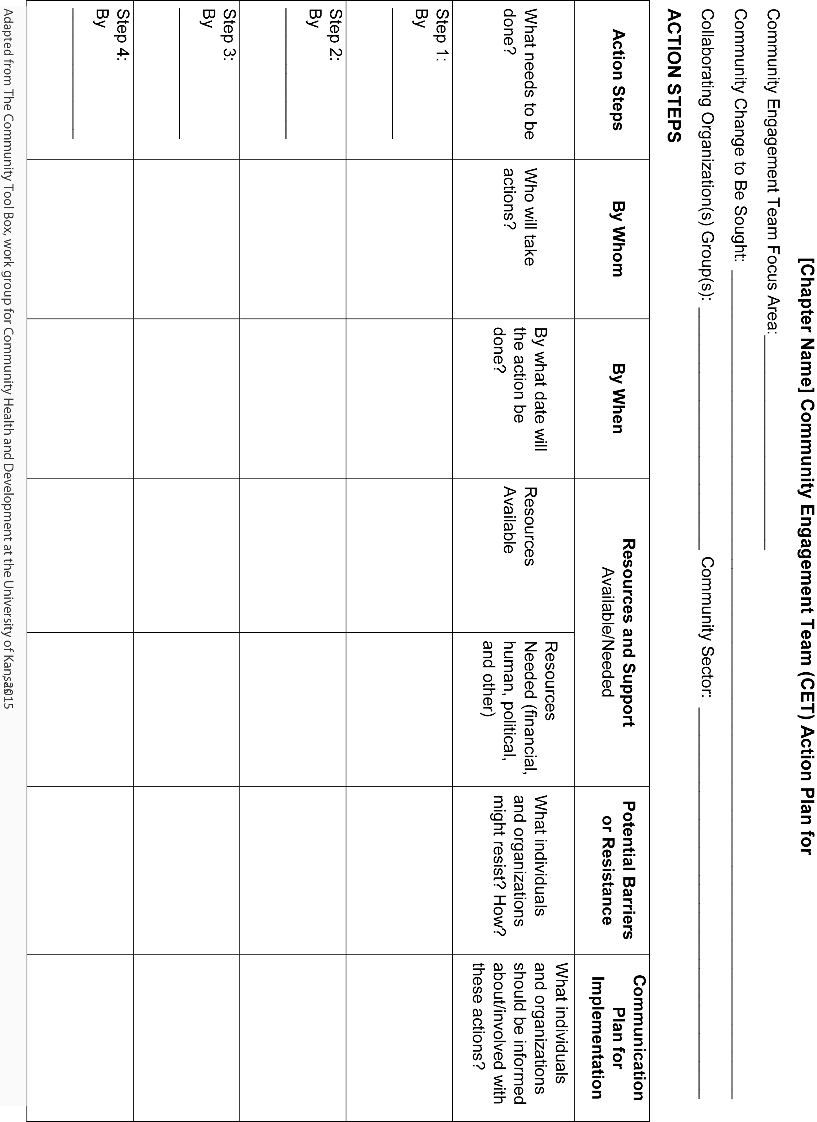
RESOURCE for STEP 6.
Execute the Plan

Turning Ideas
Into Action
From the Toolkit
7 Steps: Successful Community Engagement

Translating the Idea of Change Into Action

In its simplest form, a Community Engagement plan is an explanation of the proposed changes and the steps needed to achieve the outcome desired by the team. Marshall Ganz describes successful execution of community organizing:

“Organizing outcomes must be clear, measurable, and specific if progress is to be evaluated, and strategy adapted based on experience. Such measures include: volunteers recruited, money raised, people at a meeting, voters contacted, pledge cards signed, laws passed, etc. Although electoral campaigns enjoy the advantage of very clear outcome measures, any effective organizing drive must come up with the equivalent. Regular reporting of progress to goal creates opportunity for feedback, learning and adaptation. Training is provided for all skills (holding house meetings, phone banking, canvassing, etc.) to carry out the program. New media may help enable reporting, feedback and coordination. Transparency exists as to how individuals, groups and the campaign as a whole are doing on progress to goal.”
Marshall Ganz, Harvard University.

DISORGANIZATION | LEADERSHIP ACTIVITIES | ORGANIZATION
Passive | Shared Story | Motivated
Divided | Relational Commitment | United
Drift | Clear Structure | Purposeful
Reactive | Creative Energy | Initiative
Inaction | Effective Action | Change

RESOURCE for STEP 7.
Evaluation and Learnings

Reflecting on
The Project
From the Toolkit
7 Steps: Successful Community Engagement

Goal Attainment Report

Prior to beginning the Community Engagement project, a goal attainment report can assist in clarifying expectations and focus of work. Create a goal attainment report by answering:

What are the reasons for making a goal attainment report?
- Show progress (Determine how will you show progress?)
- Stay focused (How will the team stay focused on the outcome?)
- Communicate your good work to the public (What modes of communication will be used?)

How do you implement the process of writing a goal attainment report?
- Determine how often to gather data, usually every six months
- Write down all of your goals using your action plan
- Identify the goals you have completed
- Compute the percentage of goals completed
- Communicate your results
- Use the report to inspire positive change

Community Organizing Project Evaluation

Plus / Delta Form

Chapter:

Organizing Project Name:
Results | Went Well (+) | Ideas for Improvement (Δ)
Scope of Project

Team composition

Schedule

Clarify of Expectation

Resources

Risks

Process
Project initiation

Project planning

Monitoring

Change control

Communication

Other

Community Engagement Team

Individual Team Member Reflection Questions

- Did I do what mattered?

- Did I show up fully and take responsibility?

- Did I live and act according to my values?

- Did I model what I want to teach?

- Did I pay attention and listen?

- Did I make a positive contribution?

- What could I have done differently to improve a situation for myself or for others?

- What do I need to change?

- How can I change my behavior?

- What are my next steps to improve, build, or change what I can?

Evaluation Plan Checklist
Highlight or circle as you gain understanding
You understand that you should have an evaluation plan because: |  | Clarify the objectives and goals of your initiative:
It guides you through each step of the process of evaluation |  | Make a table of program components and elements
It helps you decide what sort of information you and your stakeholders really need |  | Develop evaluation questions:
It keeps you from wasting time gathering information that isn’t needed |  | You understand the four main categories of evaluation questions:  - Planning and implementation issues  - Assessing attainment of objectives  - Impact on participants  - Impact on the community
It helps you identify the best possible methods and strategies for getting the needed information
It helps you come up with a reasonable and realistic timeline for evaluation |  | You have considered the best possible methods to answer those questions
Most importantly, it will help you improve your initiative! |  | Develop evaluation methods to best address those questions:
You understand who your project or initiative’s stakeholders are: |  | You understand how to use the monitoring and feedback system’s three main elements (process measures, outcome measures, and observational system)
Community groups
Grantmakers and funders
University-based researchers |  | You understand how to use member surveys about the initiative (member survey of goals, member survey of process, and member survey of outcomes)
You have taken into consideration:
What stakeholders want to know about the evaluation
What decisions stakeholders need to make |  | You understand how to use behavioral surveys
How stakeholders would use the data to inform decisions |  | You understand how to use the goal attainment report
When considering how to balance costs and benefits, you have asked yourself the following questions: |  | You understand how to use interviews with key participants
What do you need to know? |  | You know how to use community-level indicators of impact
What is required by the community?
What is required by funding?
You understand these four main steps to developing an evaluation plan:
Clarify program objectives and goals
Develop evaluation questions
Develop evaluation methods
Set up a timeline for evaluation activities |  | Continued >>>

Evaluation Plan Checklist (Continued)
Highlight or circle as you gain understanding
Setting up a timeline for evaluation activities: |  | Expected evaluation products:
You understand that you should begin right now, or at least at the beginning of the initiative |  | You will make a report that you can share with everyone involved which includes effects expected by shareholders, differences in the behaviors of key individuals, and differences in conditions in the community
You’ve outlined questions for each stage of development of the initiative
You’ve completed a table listing: key evaluation questions, type of evaluation measures to be used to answer them, type of data collection, and experimental design |  | You’ve decided whether to also include specific tools (i.e., brief reports summarizing data), annual reports, quarterly or monthly reports from the monitoring system, and anything else that is mutually agreed upon between the organization and the evaluation team
You’ve determined when you feel it’s appropriate to provide feedback and reports
You will provide feedback and reports at the end of the evaluation |  | Evaluation standards:
You will also provide periodic feedback and reports throughout the duration of the project or initiative |  | You’ve decided what standards you will use to ensure an accurate and useful evaluation
You’ve decided when the evaluation will end
You’ve mapped out a proposed evaluation timeline

