Kids Not Profits is an issue advocacy campaign and growing coalition of education, parent, civil rights and community organizations calling for greater accountability and transparency for California’s charter schools. Charter schools are privately-managed, taxpayer-funded schools exempted from some rules applicable to traditional public schools.
Research and news reports have documented that this lack of accountability has led to financial gains for these private charter operators; cost taxpayers millions in waste, fraud and abuse; and had real consequences for students. State regulators have found more than $81 million in fraudulent and wasteful spending at charter schools around California. That’s why we’re supporting legislation that addresses these problems.
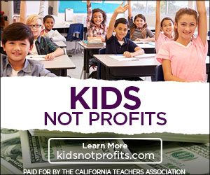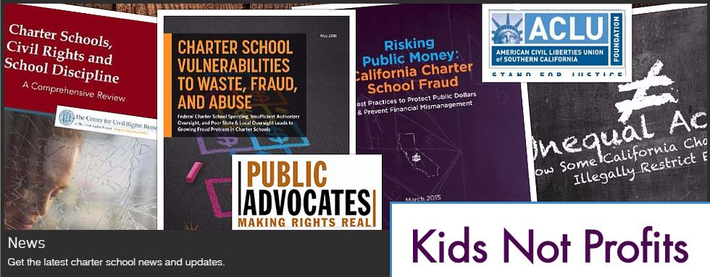
Kids Not Profits is also exposing the agenda of a group of billionaires with no experience in our classrooms, who support these privately-managed schools and who are trying to push their education agenda on the rest of us. Their agenda is simple:
• Divert money out of California’s neighborhood public schools to fund privately-run charter schools,
without accountability or transparency to parents and taxpayers.
• Cherry-pick the students who get to attend charter schools – weeding out and turning down students with special needs.
• Spend millions trying to influence local legislative and school board elections across California.
Join the coalition calling for higher standards and more accountability for these privately-run charter schools.
www.KidsNotProfits.com #KidsNotProfits

